Payroll

Testing Log Date: 09/11/26
Branch: myBranch
Last pull: BEFORE 9:46 AM

Login Page Scaling
QA Marked as Fixed: 14/09/2026
- If Windows scale is 125% (the recommended scaling), page loads like this: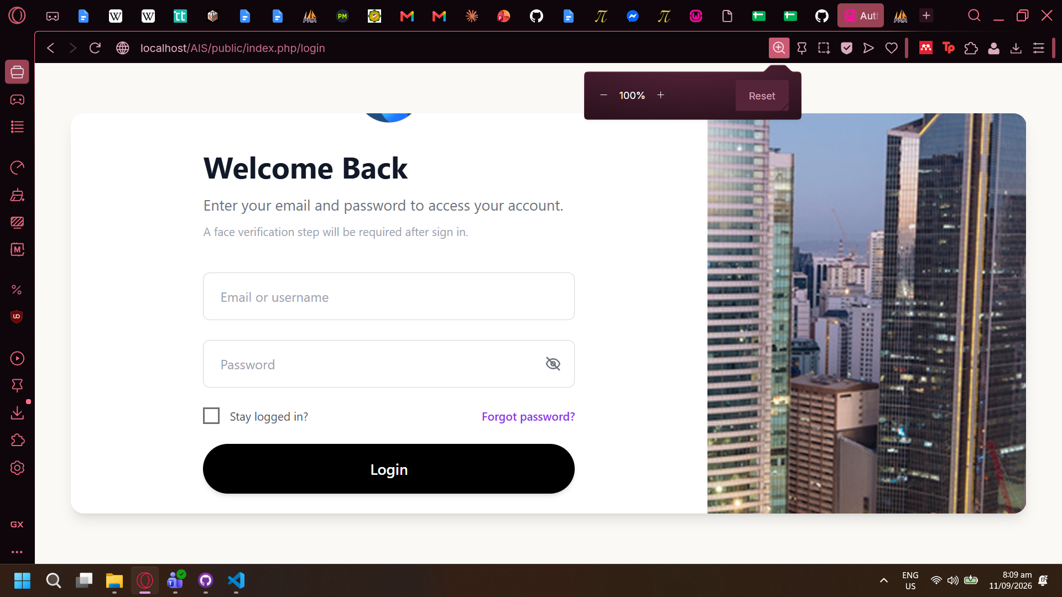
- Windows display settings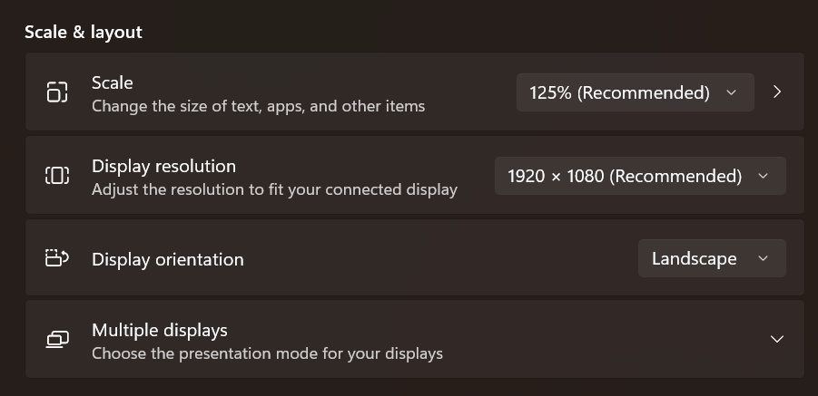
- Developers worked with 100% Windows scaling or 75% browser scaling, or etc.

Forgot Password not Functional
QA Marked as Fixed: 14/09/2026
- Forgot Password not functional
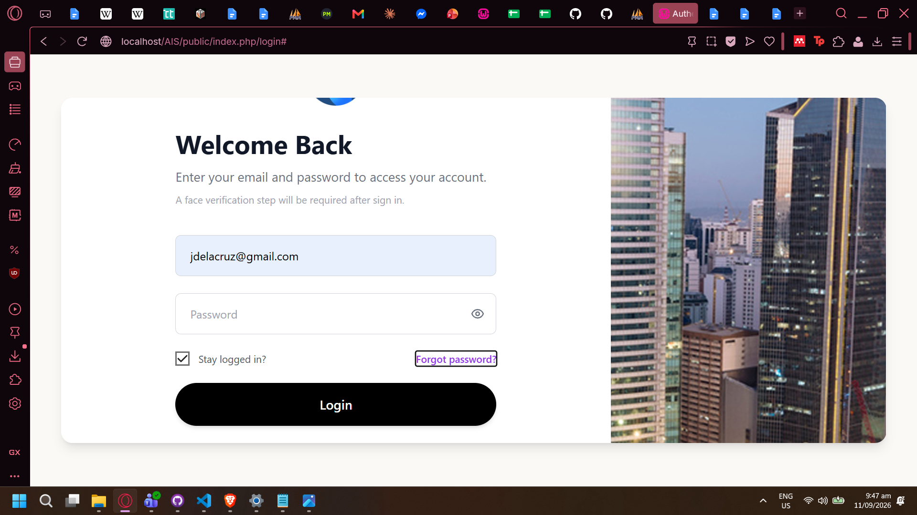
- No validation feedback if no email input for Forgot Password

Mark all as Read not functional
QA Marked as Fixed: 14/09/2026
- Mark all as read does not remove icon badges
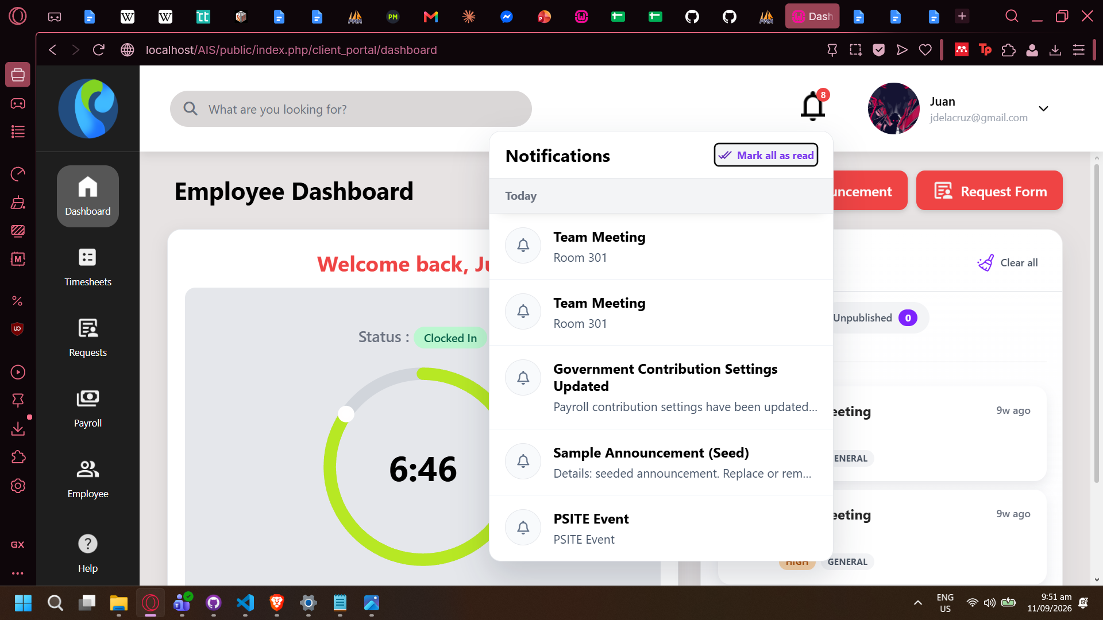

“Edit triggered” Info modal does not appear on top
QA Marked as Resolved: see “Edit Announcement on Notification Modal”
- Edit announcement triggers Info modal, but does not appear on top of announcement modal
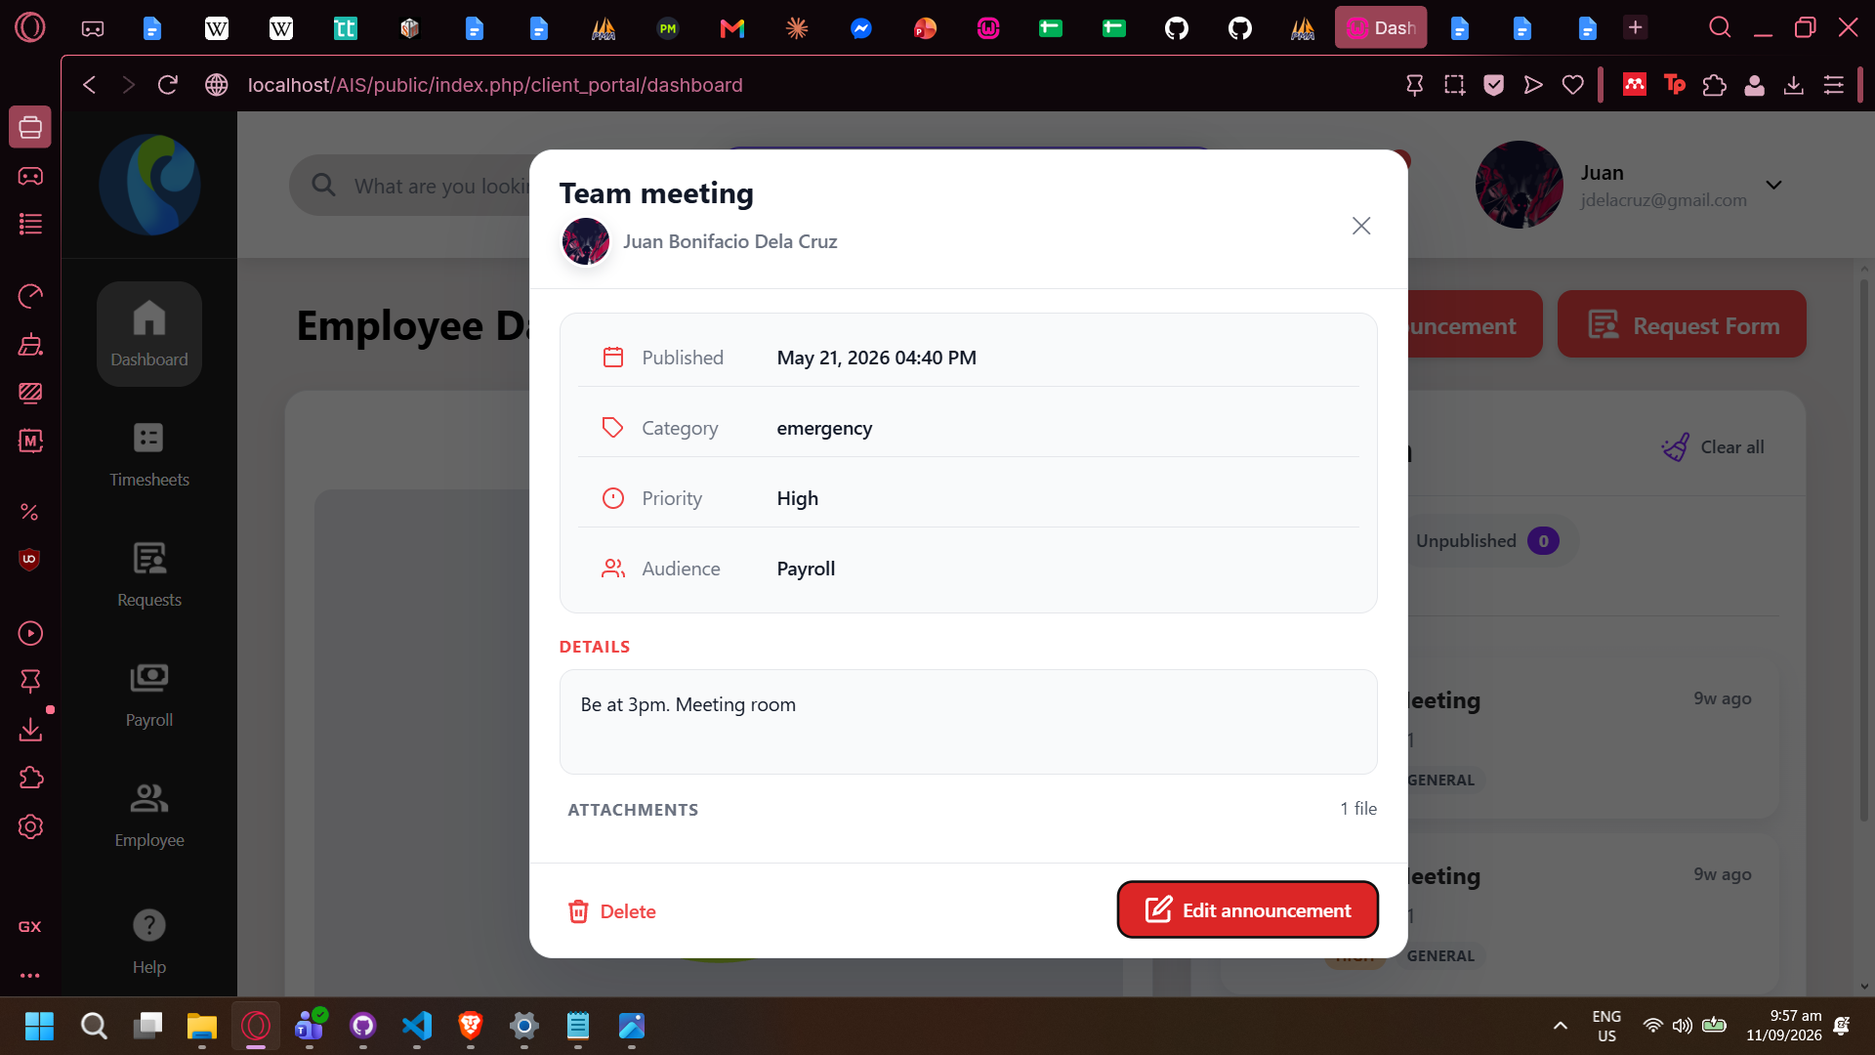
- 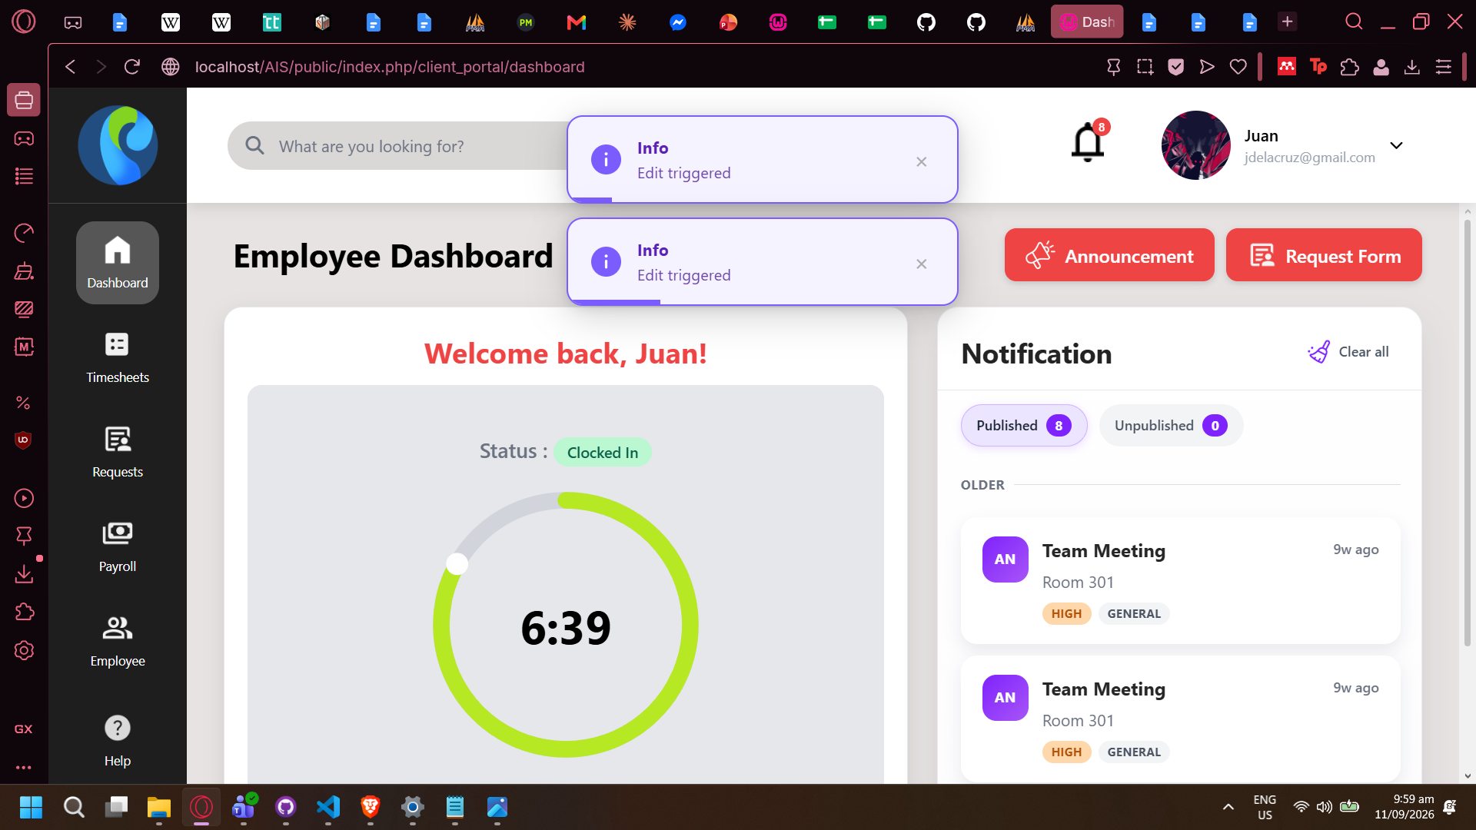

Edit Announcement on Notification Modal
QA Marked as Fixed: 15/09/26
- Edit announcement only triggers info modal, is not functional for editing announcement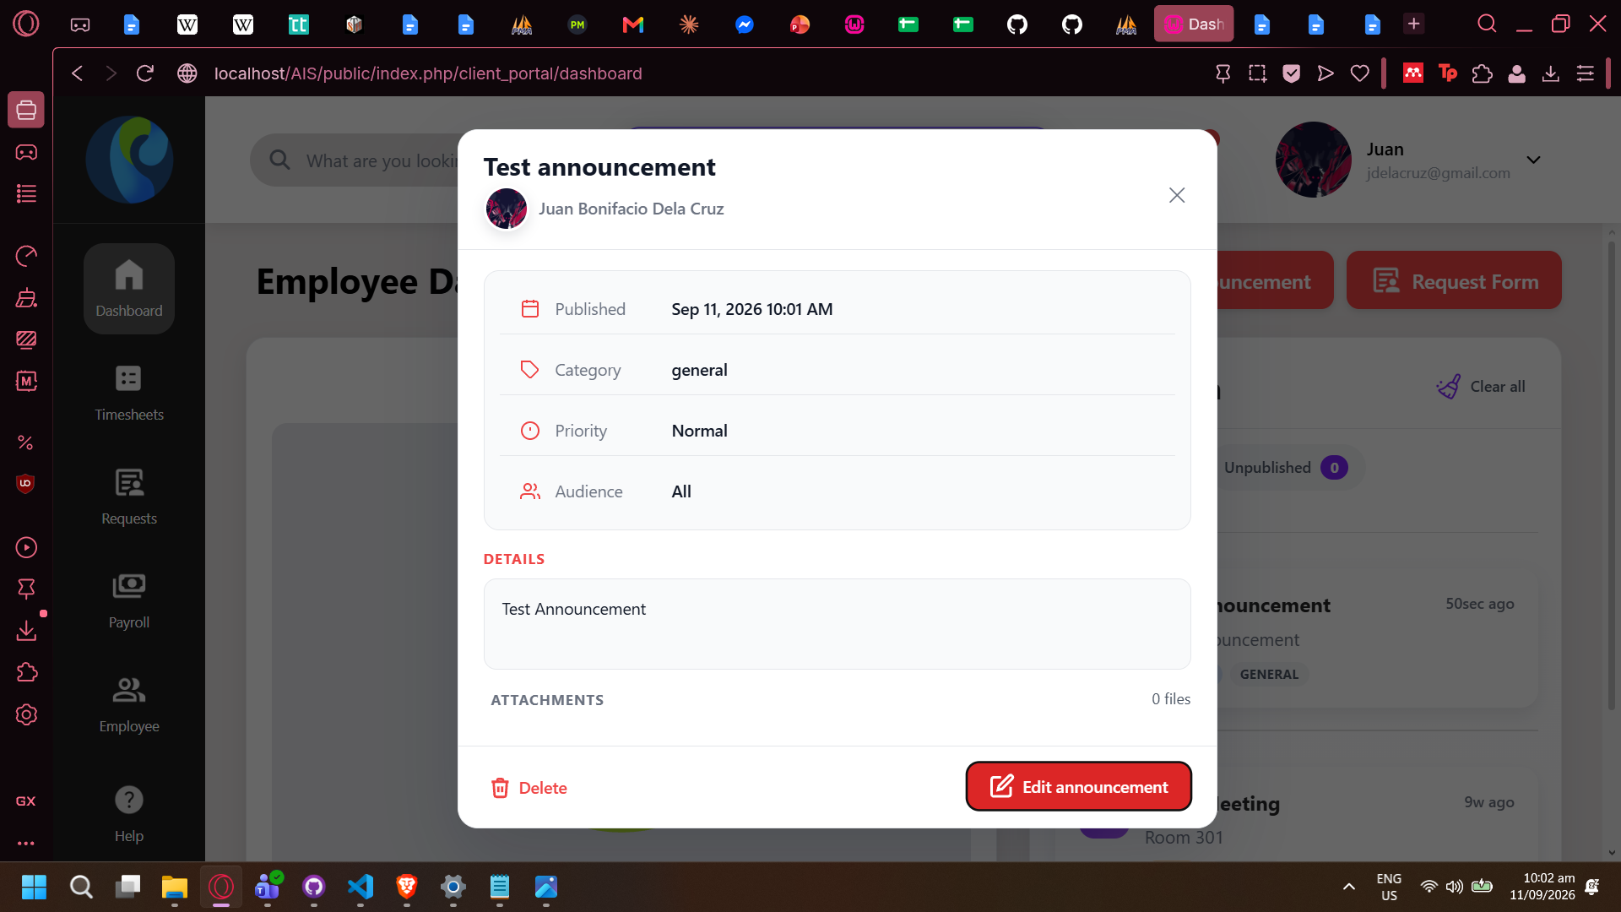
- Edit Announcement button is also visible when viewing announcements made by others. Button press also triggers Info modal (“Info: Edit triggered”).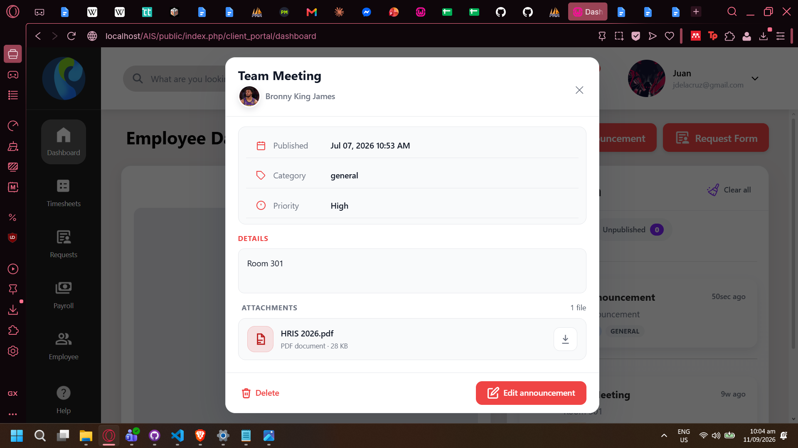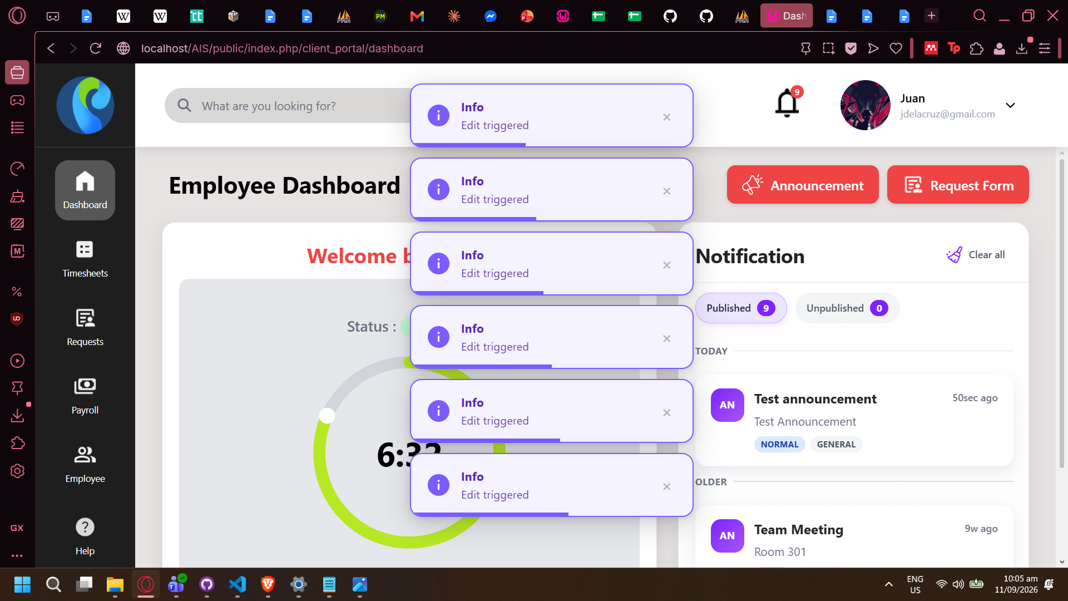

No validation feedback when downloading non-existent file from announcement (Fix Sept 11 - Theodore)
QA Marked as Fixed: 15/09/26
- No feedback modal, message, etc after download button press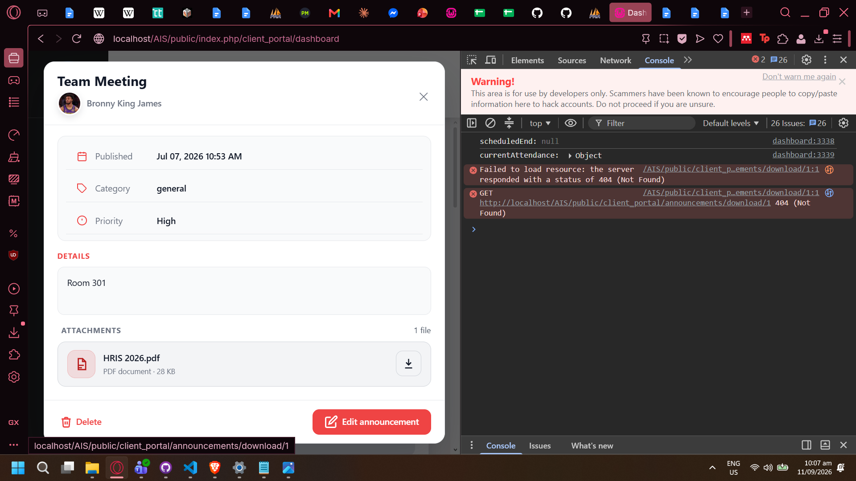
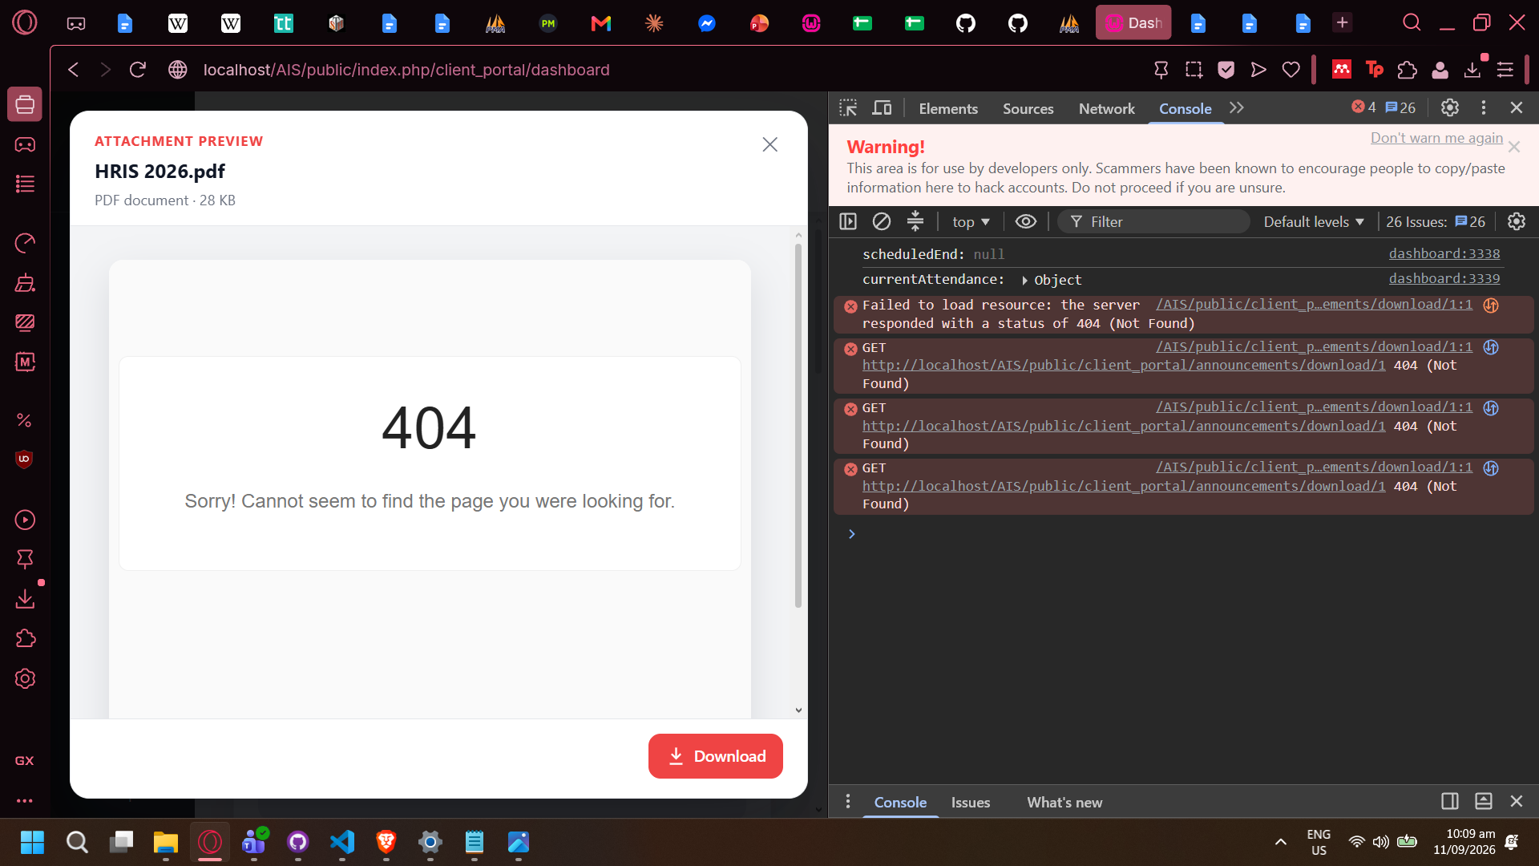
- No file is loaded either. QA unsure where it should exist.
- Resource supposed to be loaded from: (supposedly) http://localhost/AIS/public/client_portal/announcements/download/1
- Attempting to downloading file does not do anything. No console message, feedback pop up.

No autorefresh for unpublished posts (Fix Sept 11 - Theodore)
QA Marked as Fixed: 15/09/26 With comment (See below)
- Notification icon badges and Notification area does not auto refresh
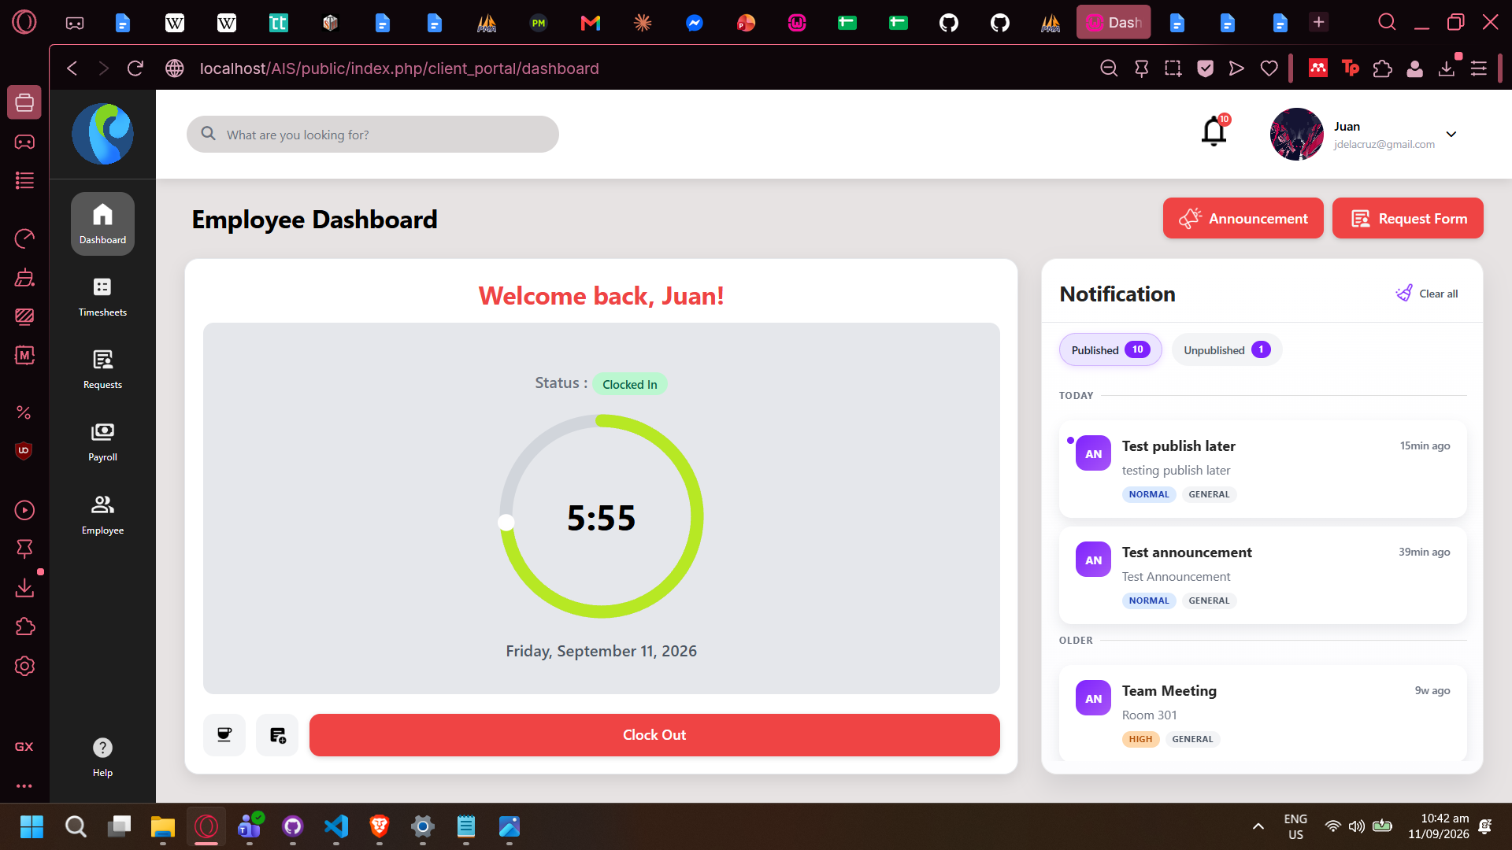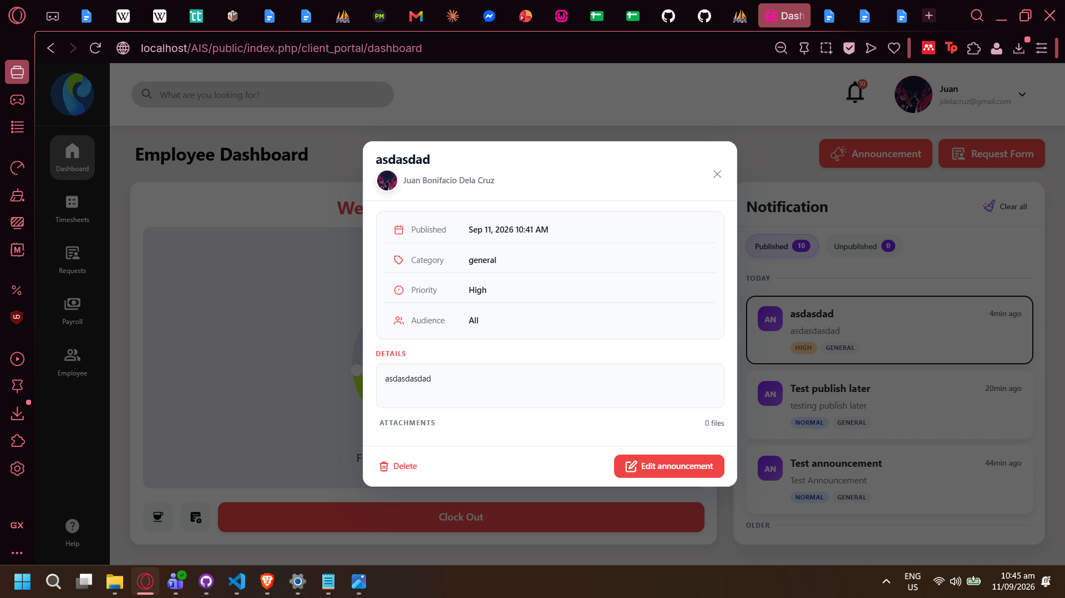
- (15/09/26) COMMENT: Other employees (not the author of announcement) do not have auto-refresh, needs to reload page to see notification

(Re: Scaling Issue) Request Form does not have scroll bar ( Fix Sept 11 - Theodore)
QA Marked as Fixed: 15/09/26
- Windows display scale setting: 125% (Recommended by Windows)
Page zoom scaling on Browser (Opera GX shown in picture below): 100%
- Form is cut off with no scroll bar to compensate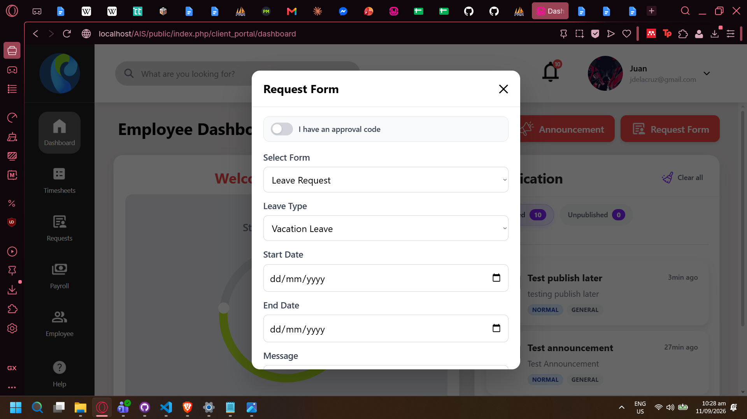
- Rest of form is only accessible by changing Page zoom scaling. (Min 75% on 1920 by 1080) Minimum is 67% on Brave Browser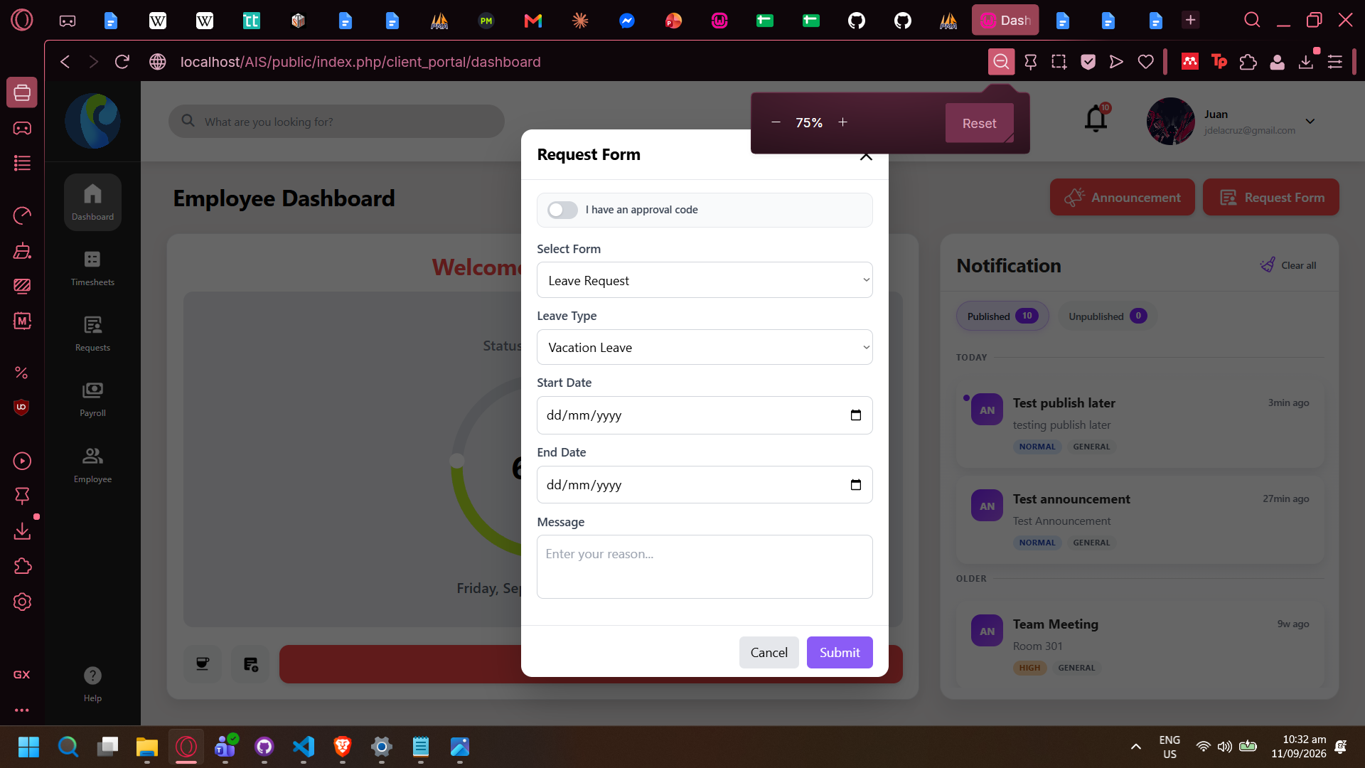
- (Browser shown in picture below is Brave) With form filled out, user has to zoom out further to complete form.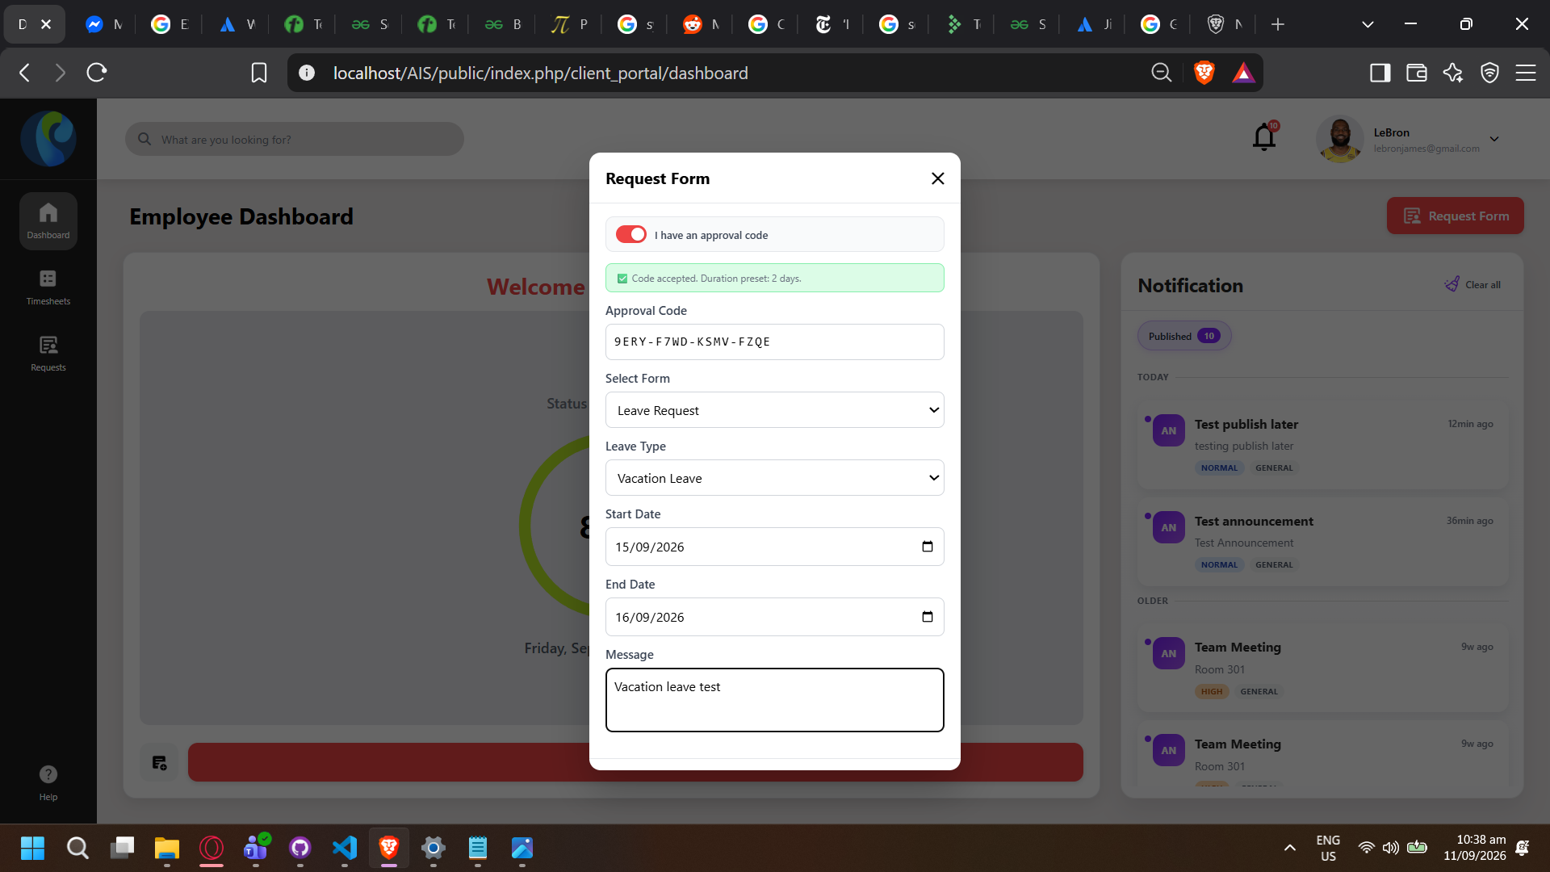
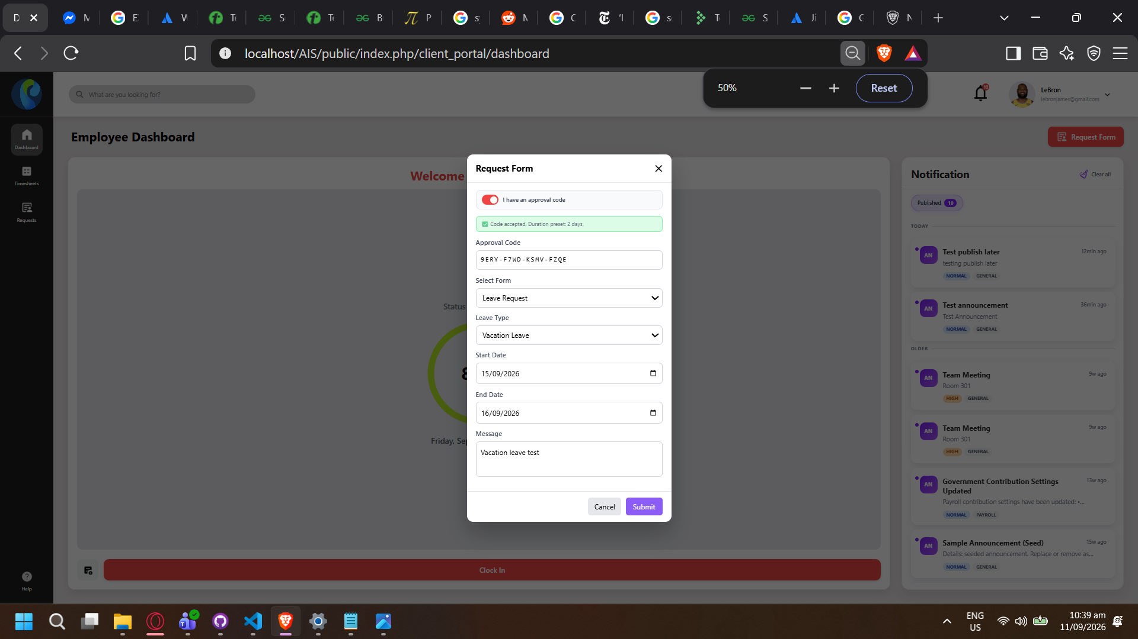

Timesheet Table Scrolls without Table Head ( Fix Sept 11 - Theodore )
QA Marked as For Review After Re-Test: 15/09/26
- Data is horizontally scrollable but Table Head is not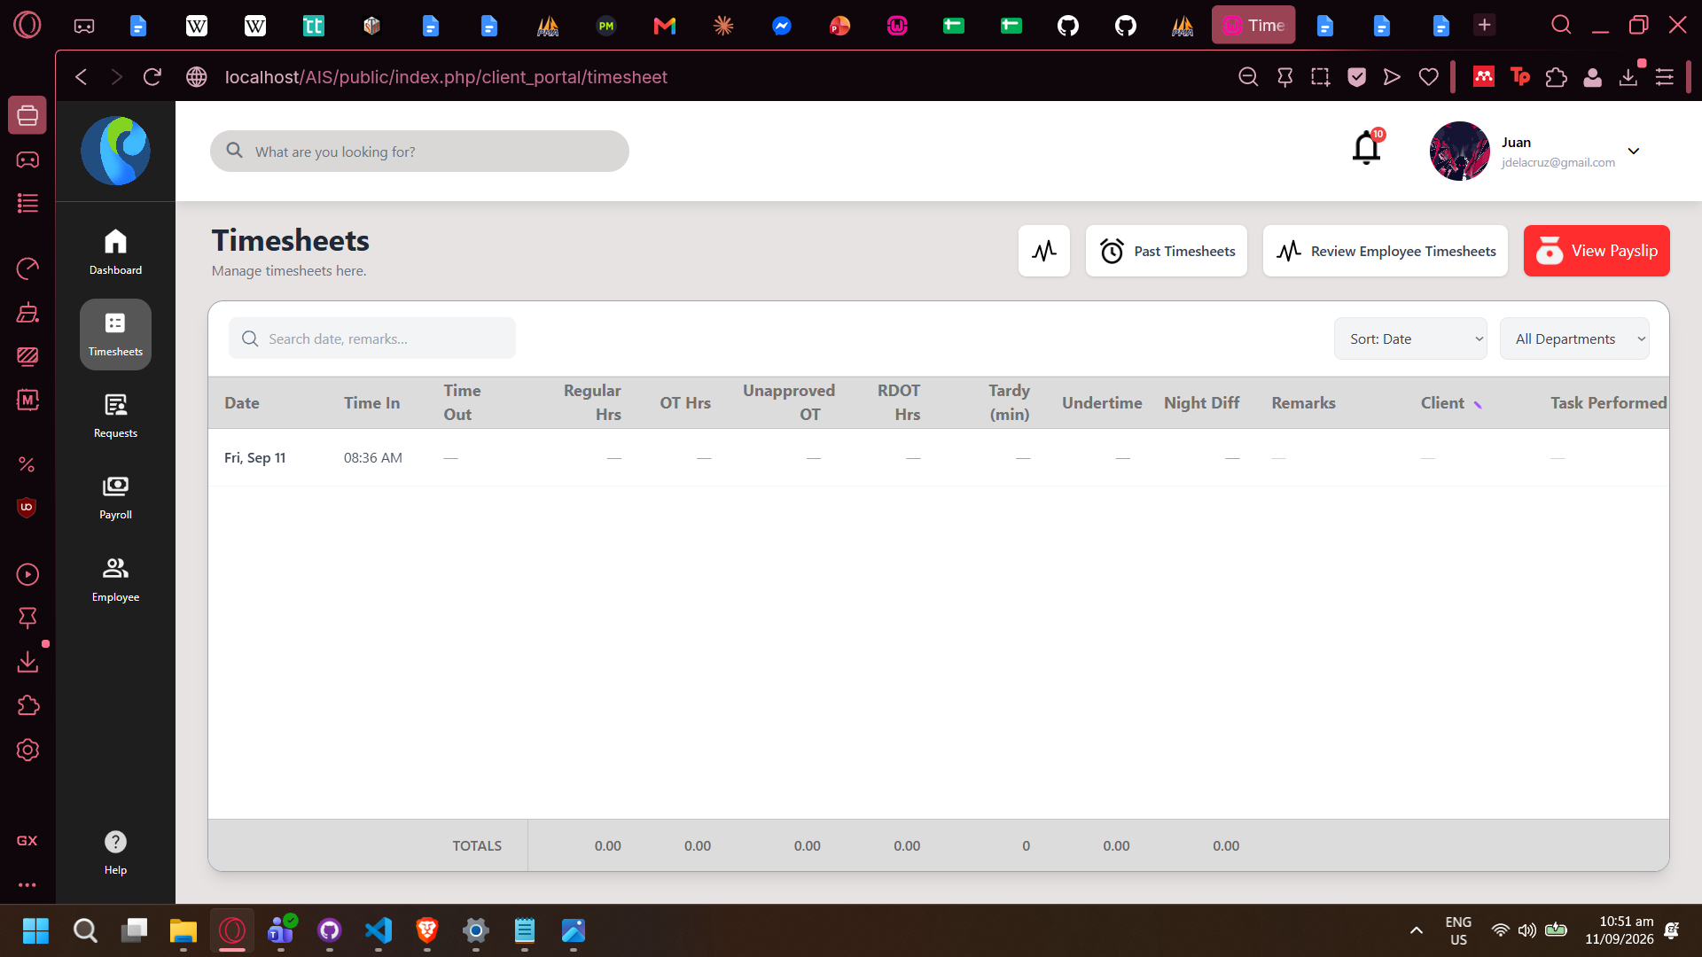
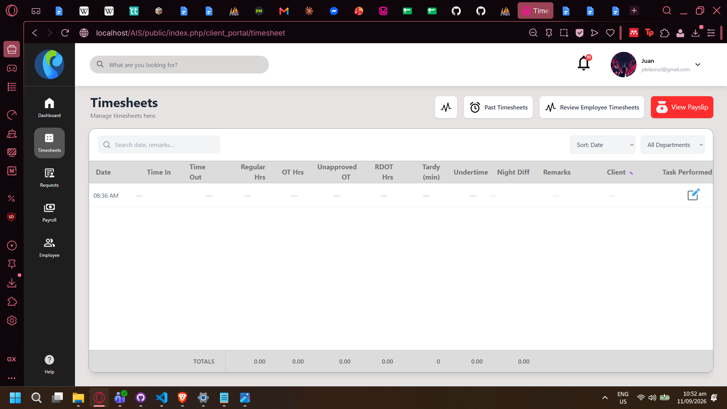
Related to scaling issue?
- (15/09/26)
Table head still does not scroll with table data
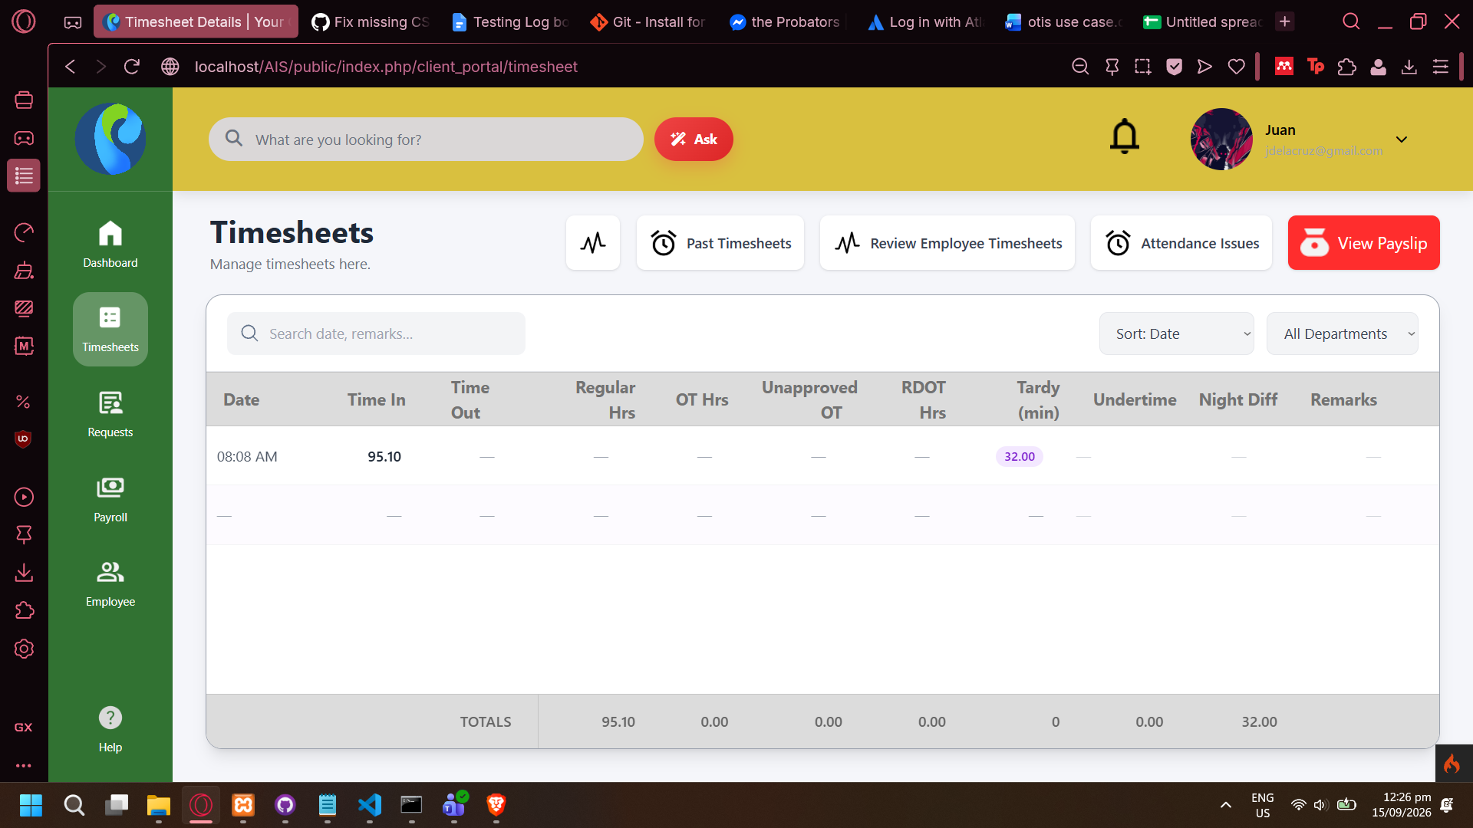

!!!QA PULLED 2 COMMITS!!!
!!!QA switched from wamp to xampp!!! 09/11/26 2:53PM

Company Customizations Settings Form not responsive (fix Sept 11 - Theodore)
QA Marked as Fixed: 15/09/26
- Container for Form Submit is sticky to bottom of page (basta yon)
- See Company Colors and Company Logo containers.
- Zoom in to see issue.
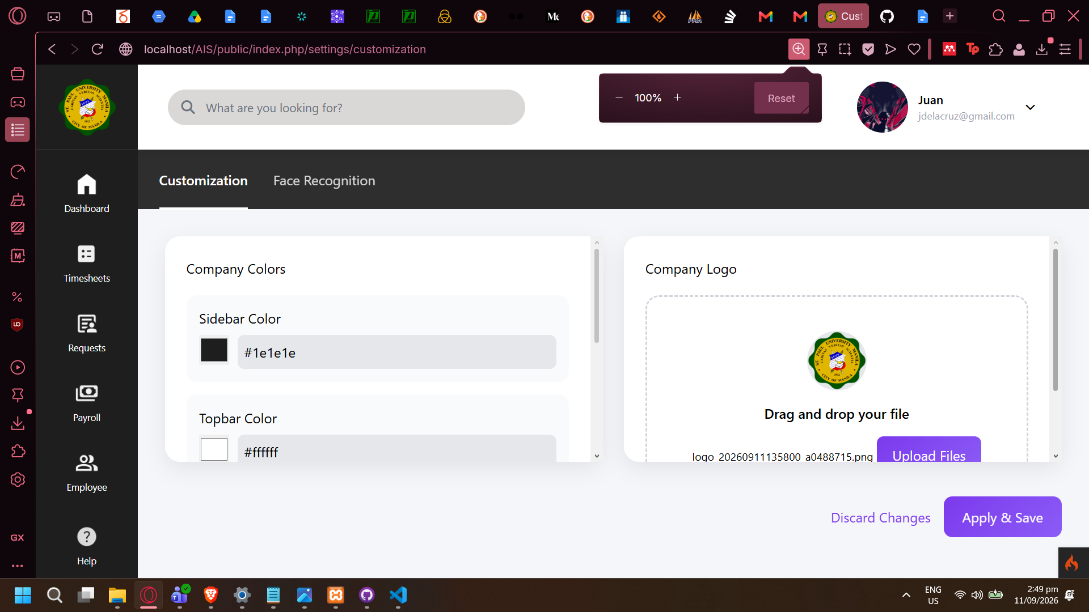
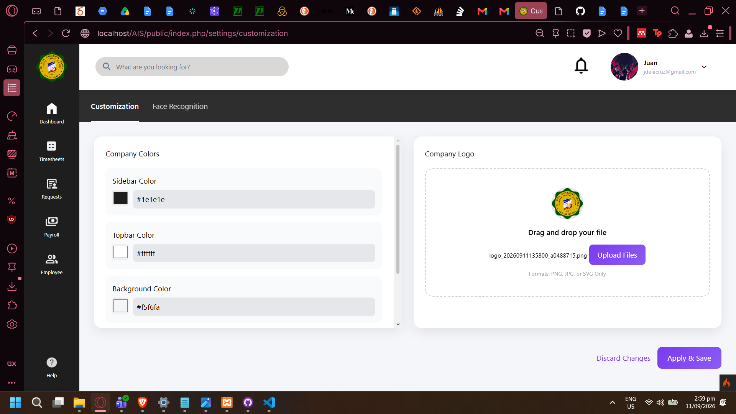

Drag and drop does not work in Company Customization Settings
QA Marked as Fixed: 15/09/26
- Drag and drop not functional
- Browser: Opera GX
- See previous bug report above for picture.

Download Payslip not Working DEVS, DISREGARD!
- Dependency issue in QA’s copy. Composer updated but vendors/ was not.
- Working now! - QA

Wrong User Leave Approval: Error Page Instead of Validation Feedback (fix sept 15 - stanley)
- Using IT super admin account with no authorization to approve leaves. Trying to approve should display pop-up stating the action is not allowed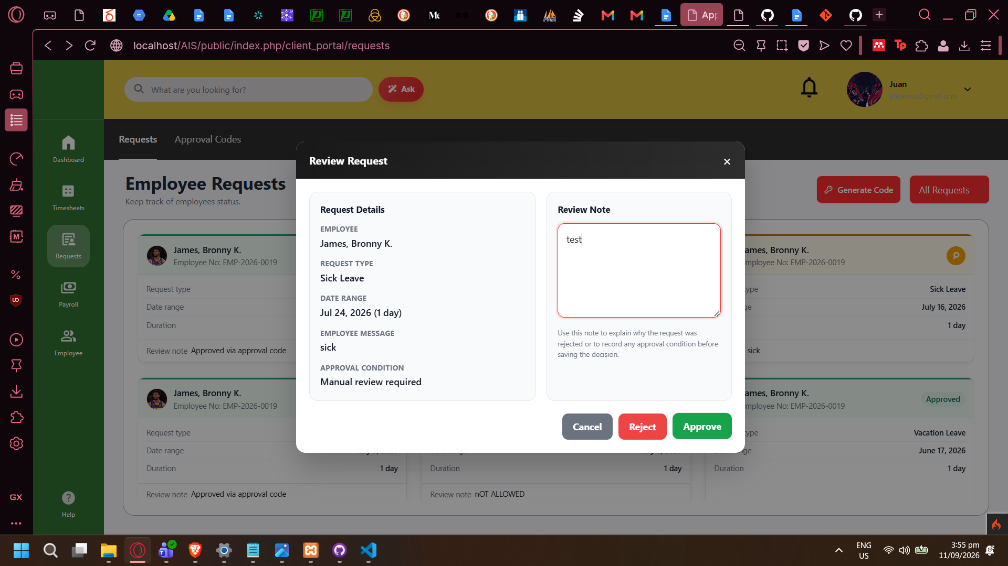
- Error page is thrown instead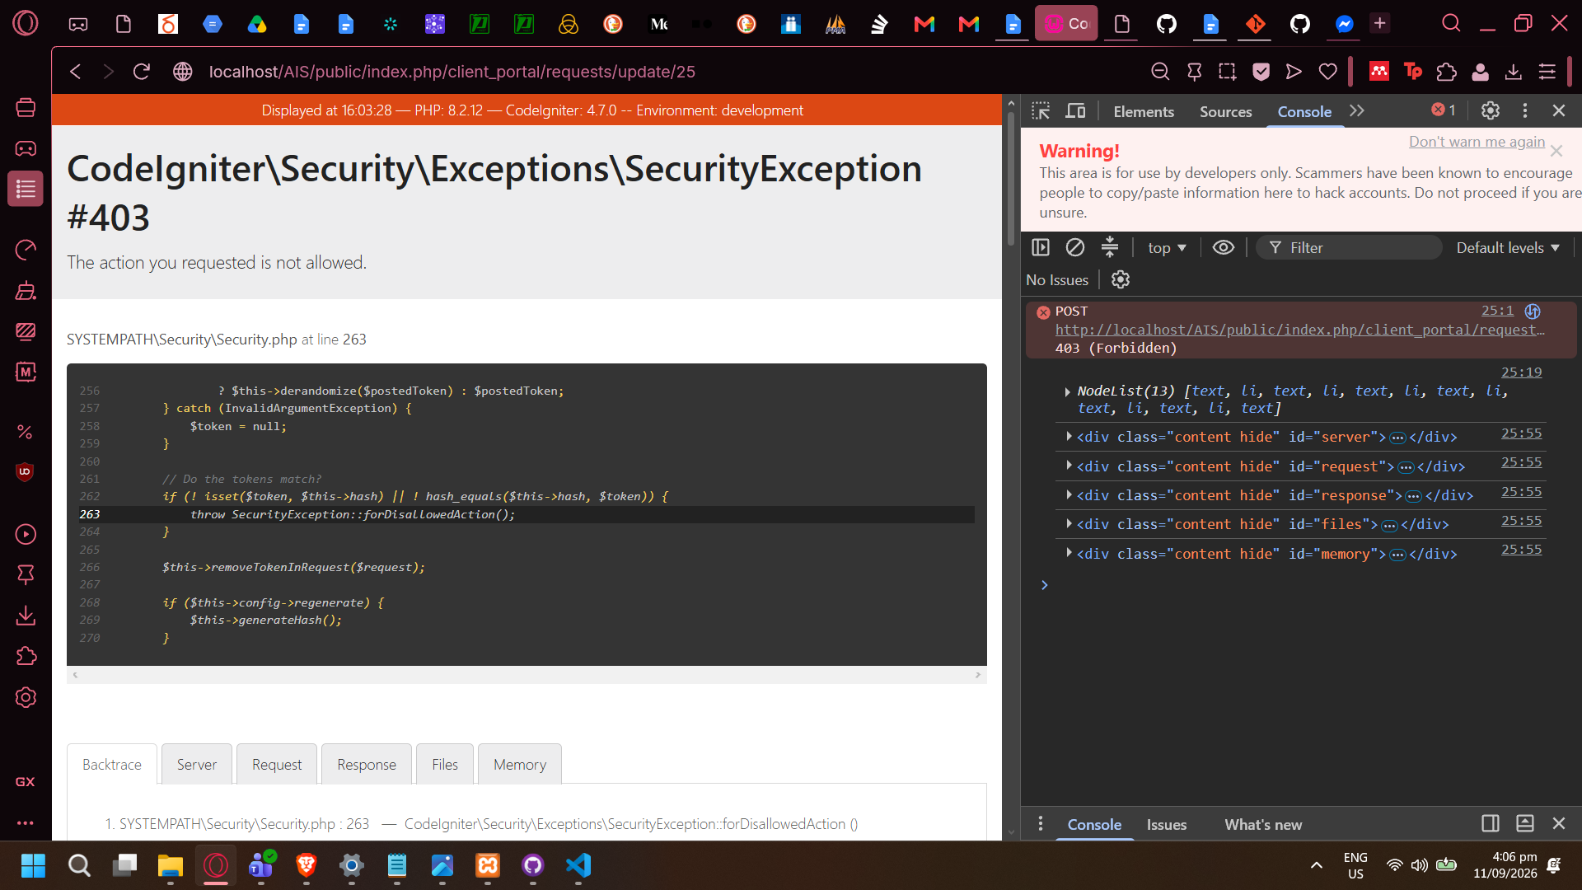

Testing Log Date: 09/14/26
Branch: myBranch
Last pull: 8:00 AM

View Payslip Scaling Issue (fix sept 15 - stanley)
- View Payslip not responsive at 100% scale (Refer to previous scaling issues in this document)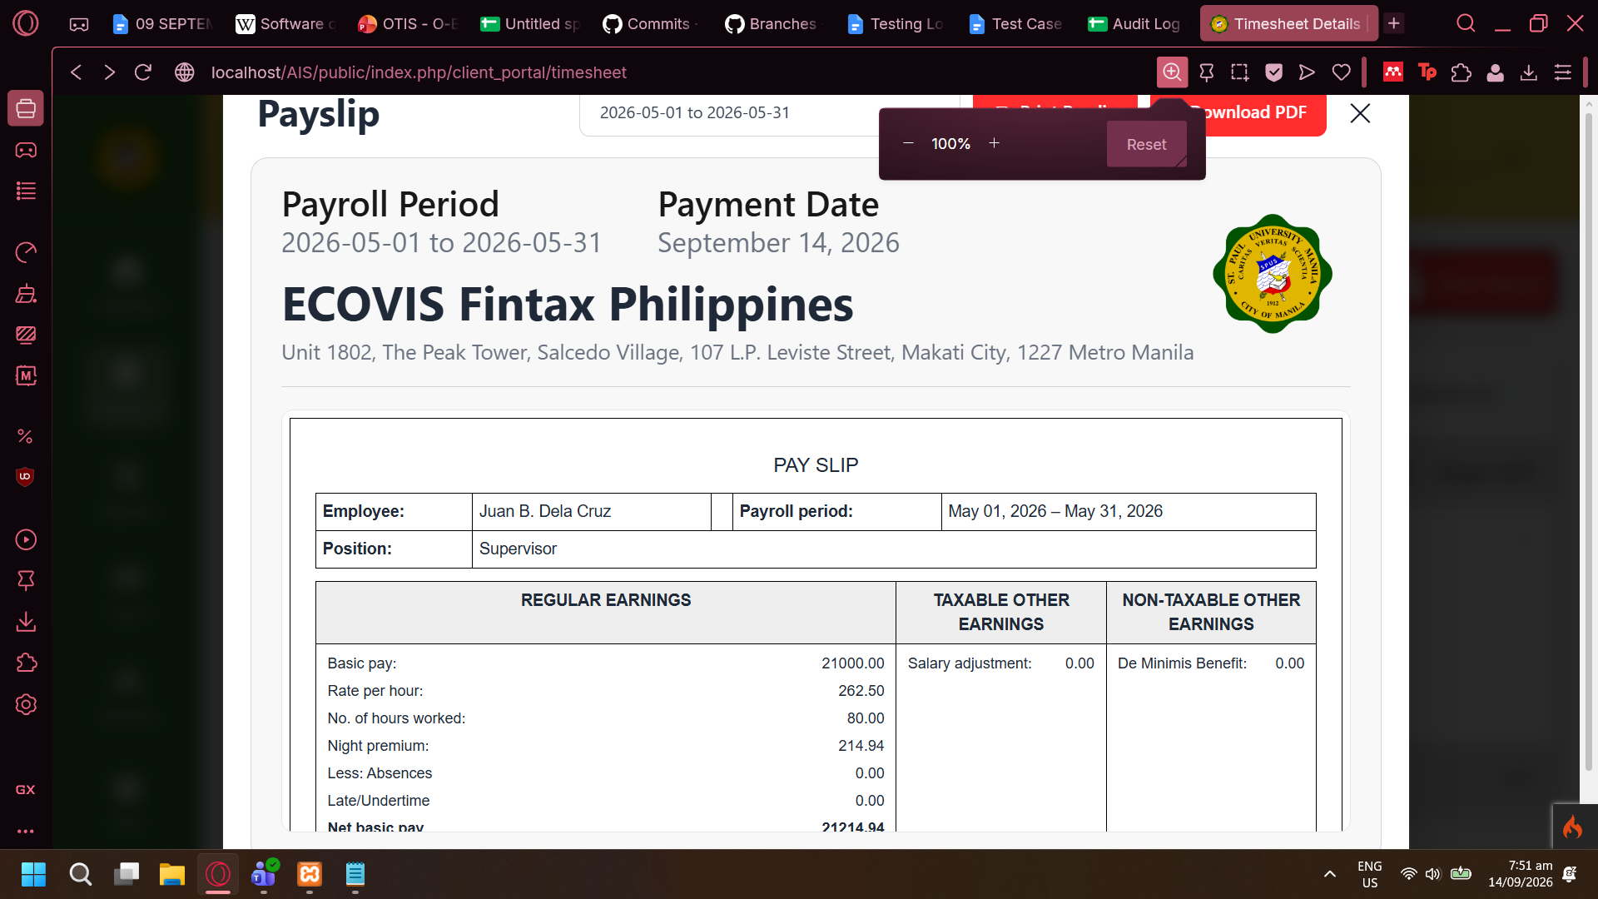

Print Payslip bypasses password protection (fix sept 15 - stanley)
QA Marked as Fixed: 15/09/26
- From Print Payslip, using Save to PDF option does not save a password-protected PDF file
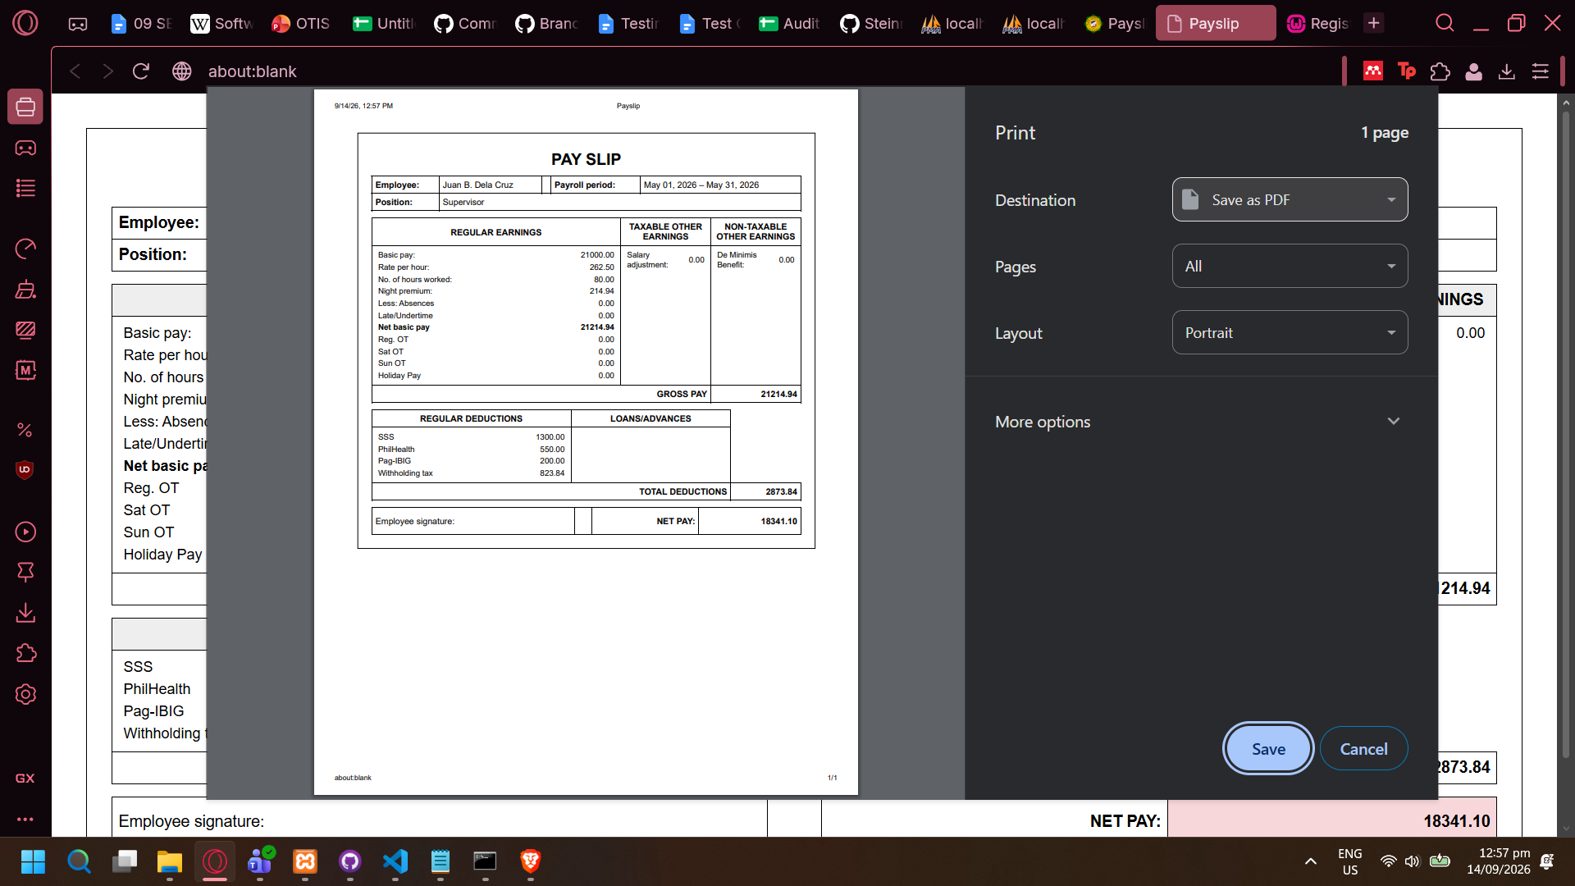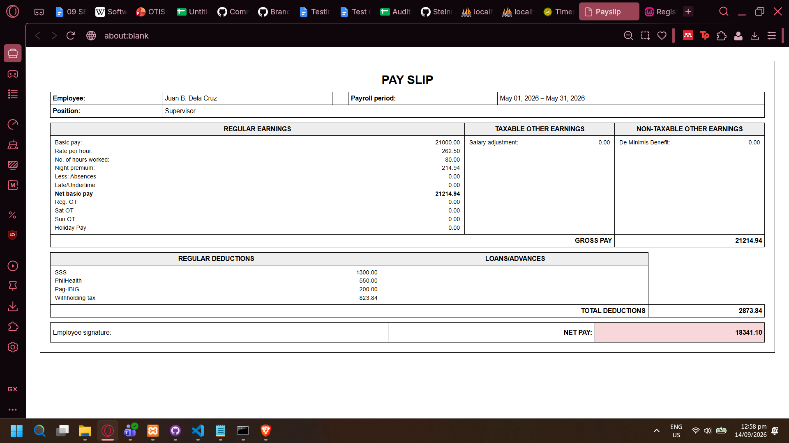

Mark Paid is forbidden even when using Payroll Staff account
- Fix found: Added missing X-CSRF Token and CSRF Hash in header on payroll_status
- Error in console log: payroll?month=2026-09&period=monthly:2517 POST http://localhost/AIS/public/index.php/client_portal/payroll/markStatus 403 (Forbidden)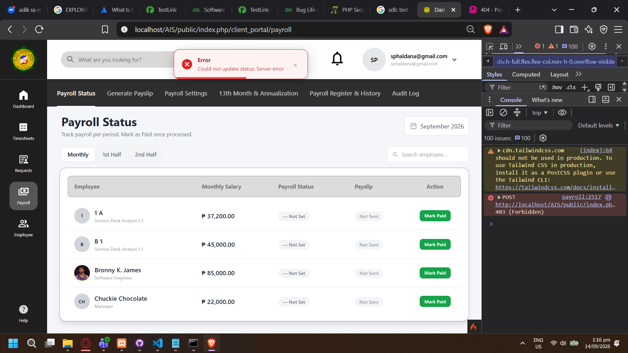

Send Payslip to Employee not working: 403 Forbidden (fix sept 15 - Stanley)
QA Marked as Fixed: 15/09/26
- Error encountered when sending PDF Payslip to employee even on authorized account type.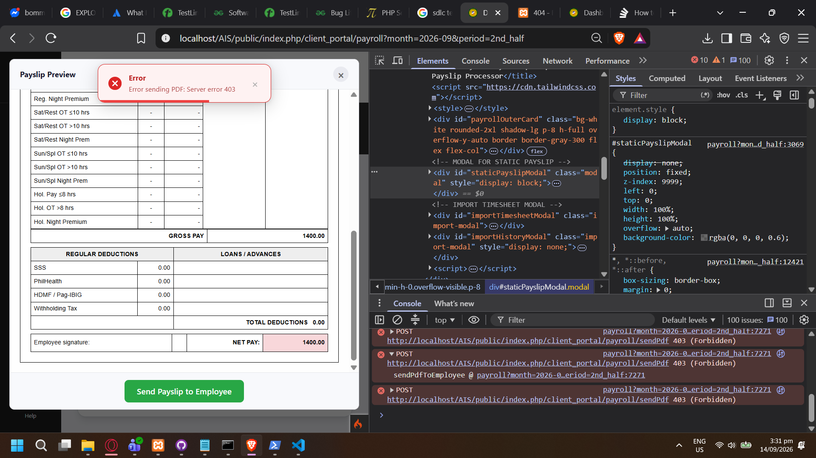
- Sending in Bulk Payslip also doesn’t work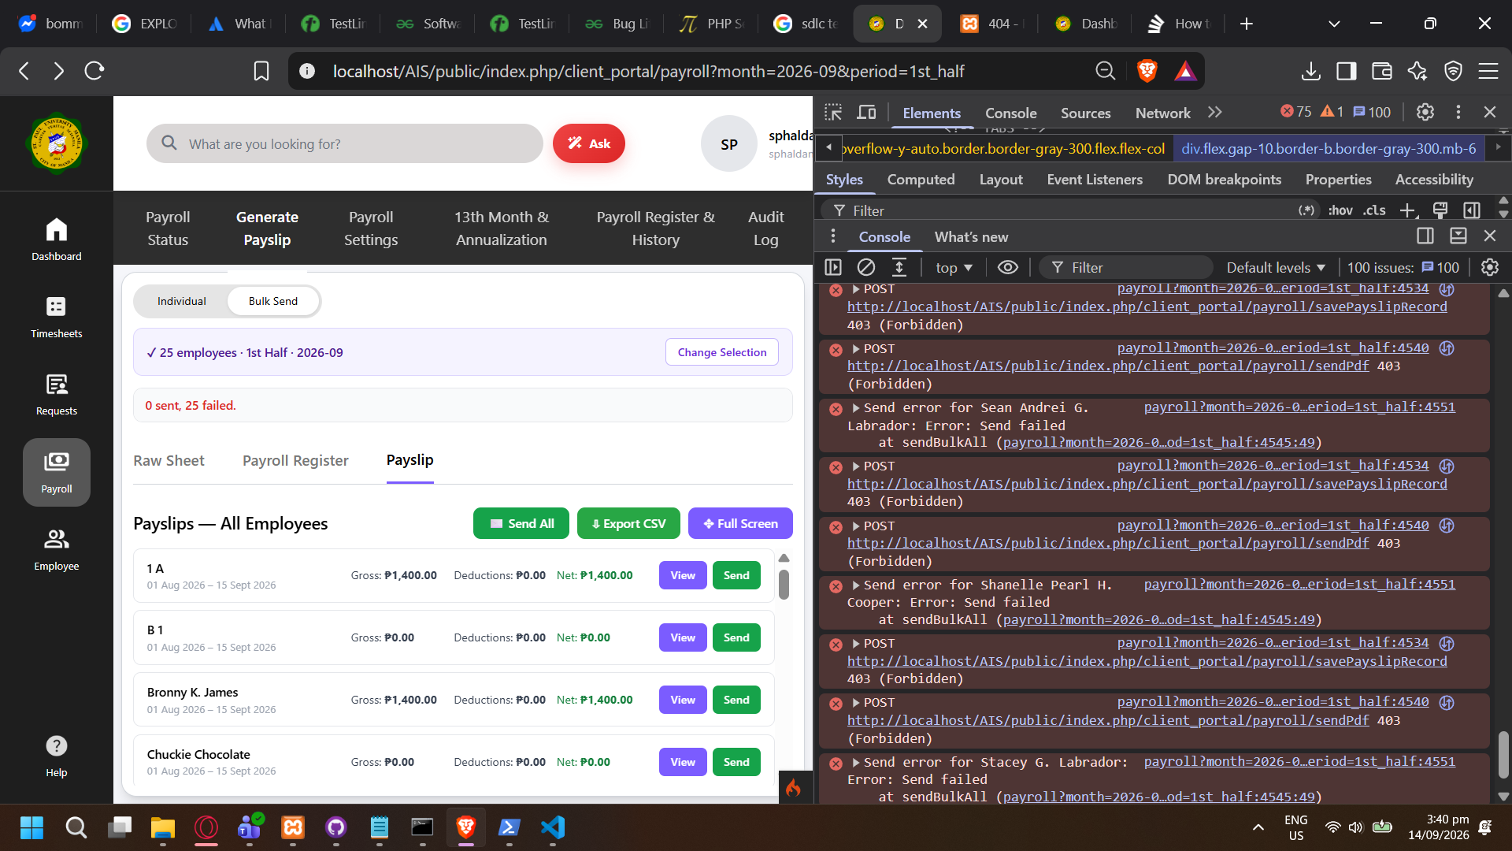

Cannot Update Employee, and redirects to different page (fix sept 15 - Stanley)
QA Marked as Fixed: 15/09/26
- Forbidden from Update Employee despite using Client Payroll Staff account. 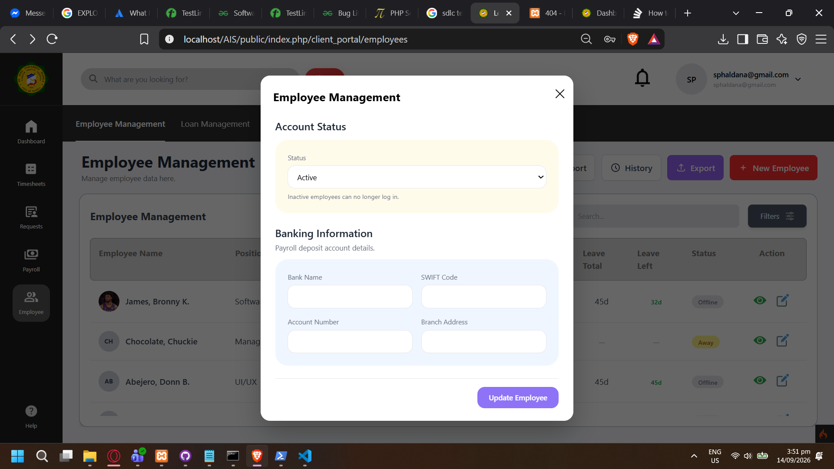
- Upon clicking button it redirects to this page instead of usual error page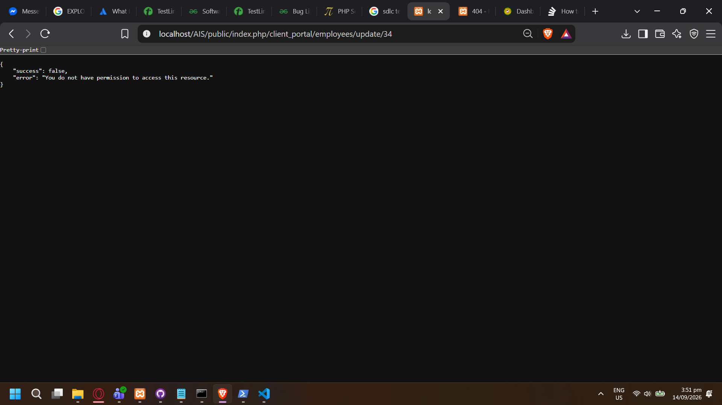

Cannot Approve Leave (fix Sept 15 - Stanley)
QA Marked as Fixed: 15/09/26
- Action requested is not allowed despite using HR Admin account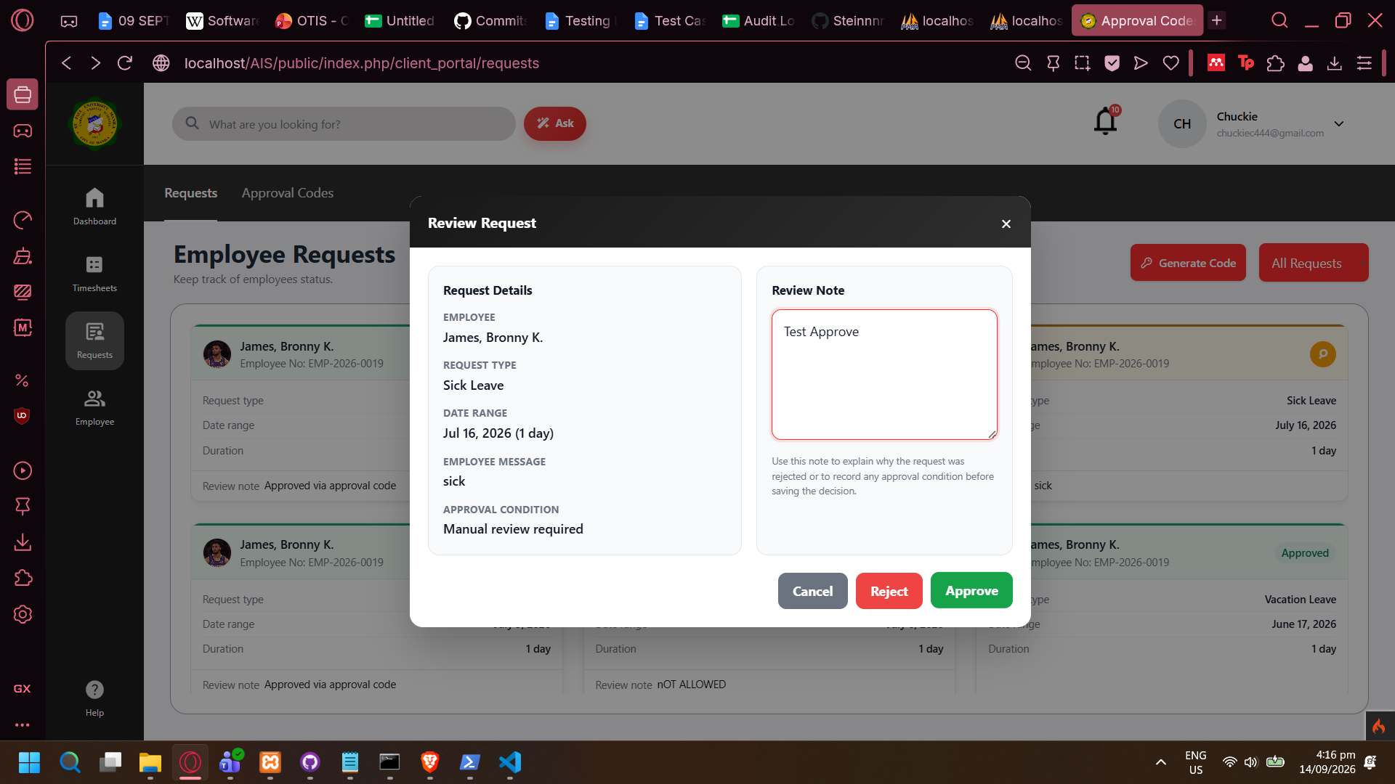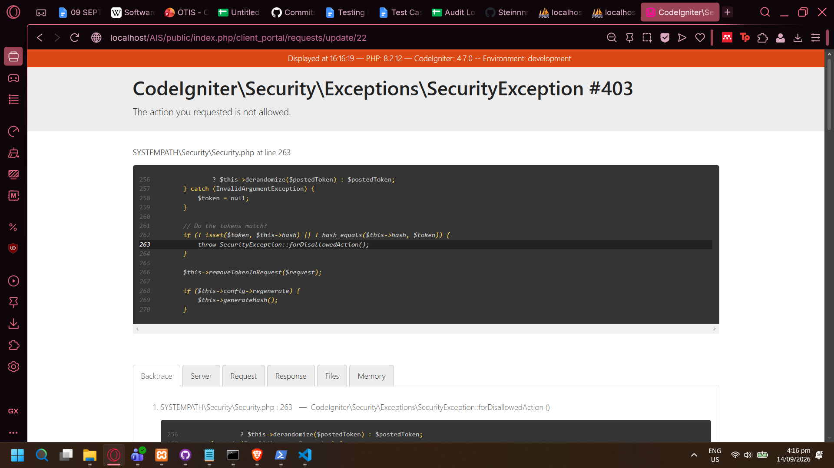

Testing Log Date: 15/09/26

Cannot update Payroll Settings
Marked as Needs Retest
- Upon clicking Save Settings (Regardless if data was changed or not), redirects to error page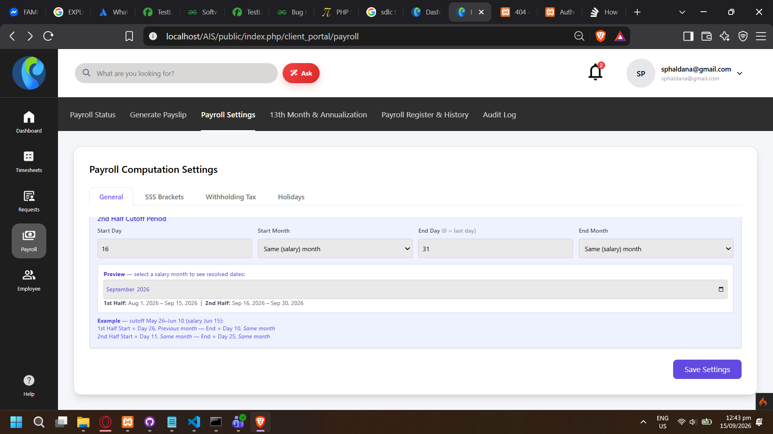
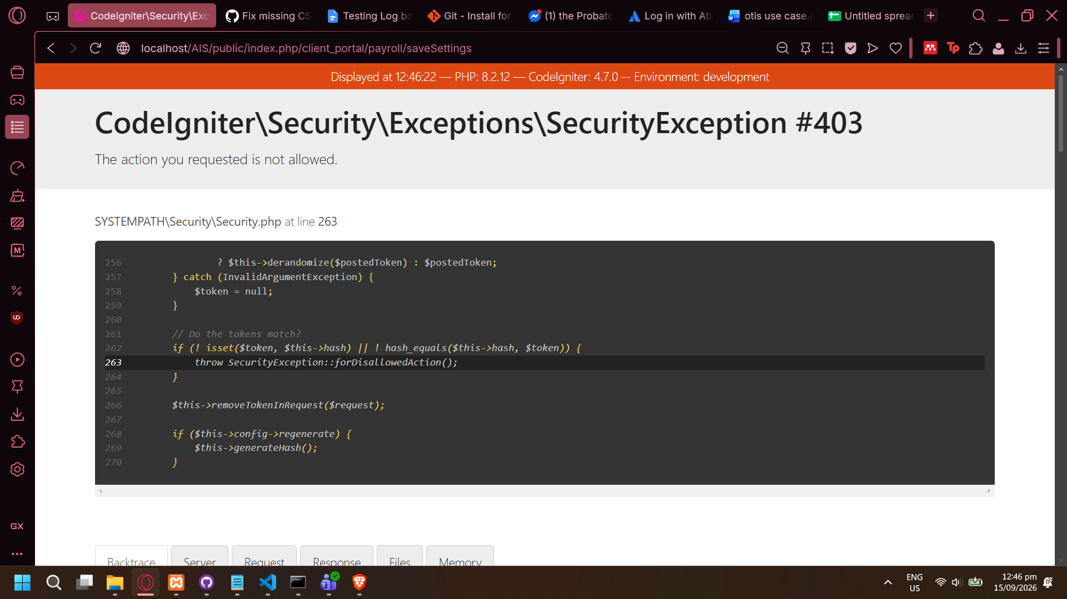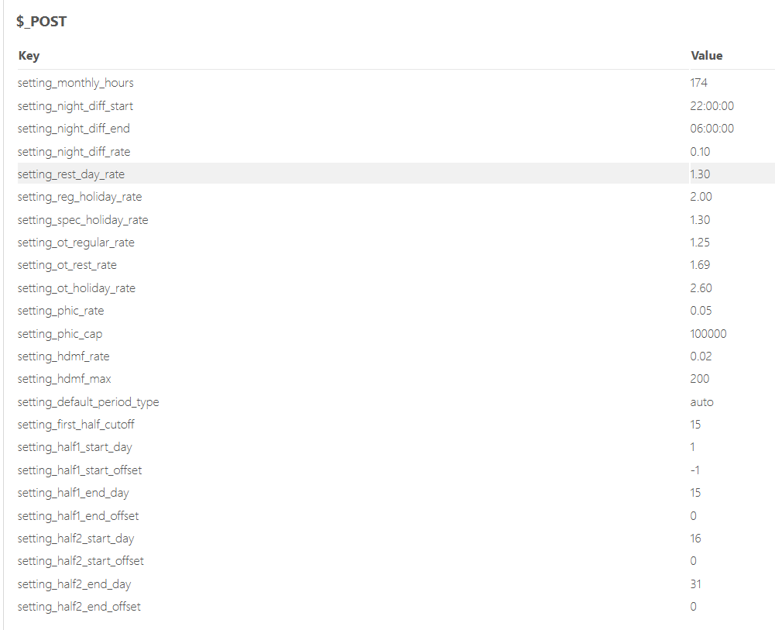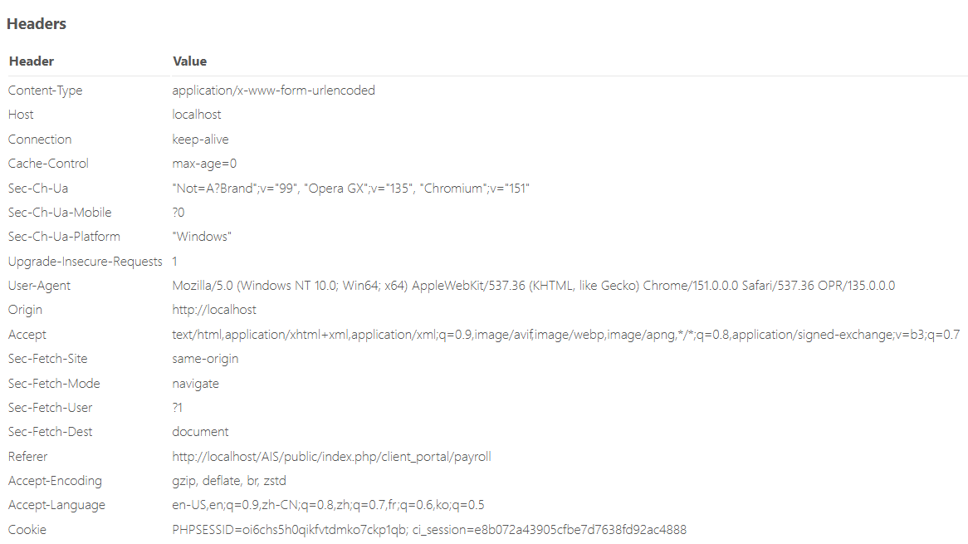
- 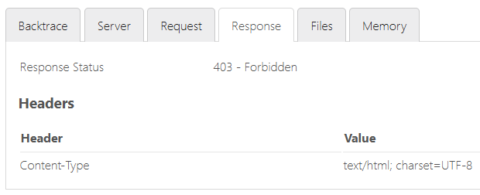

Cannot apply 13th month pay to employee
Marked as Needs Retest
- No validation feedback, no pop-up to indicate unsuccessful action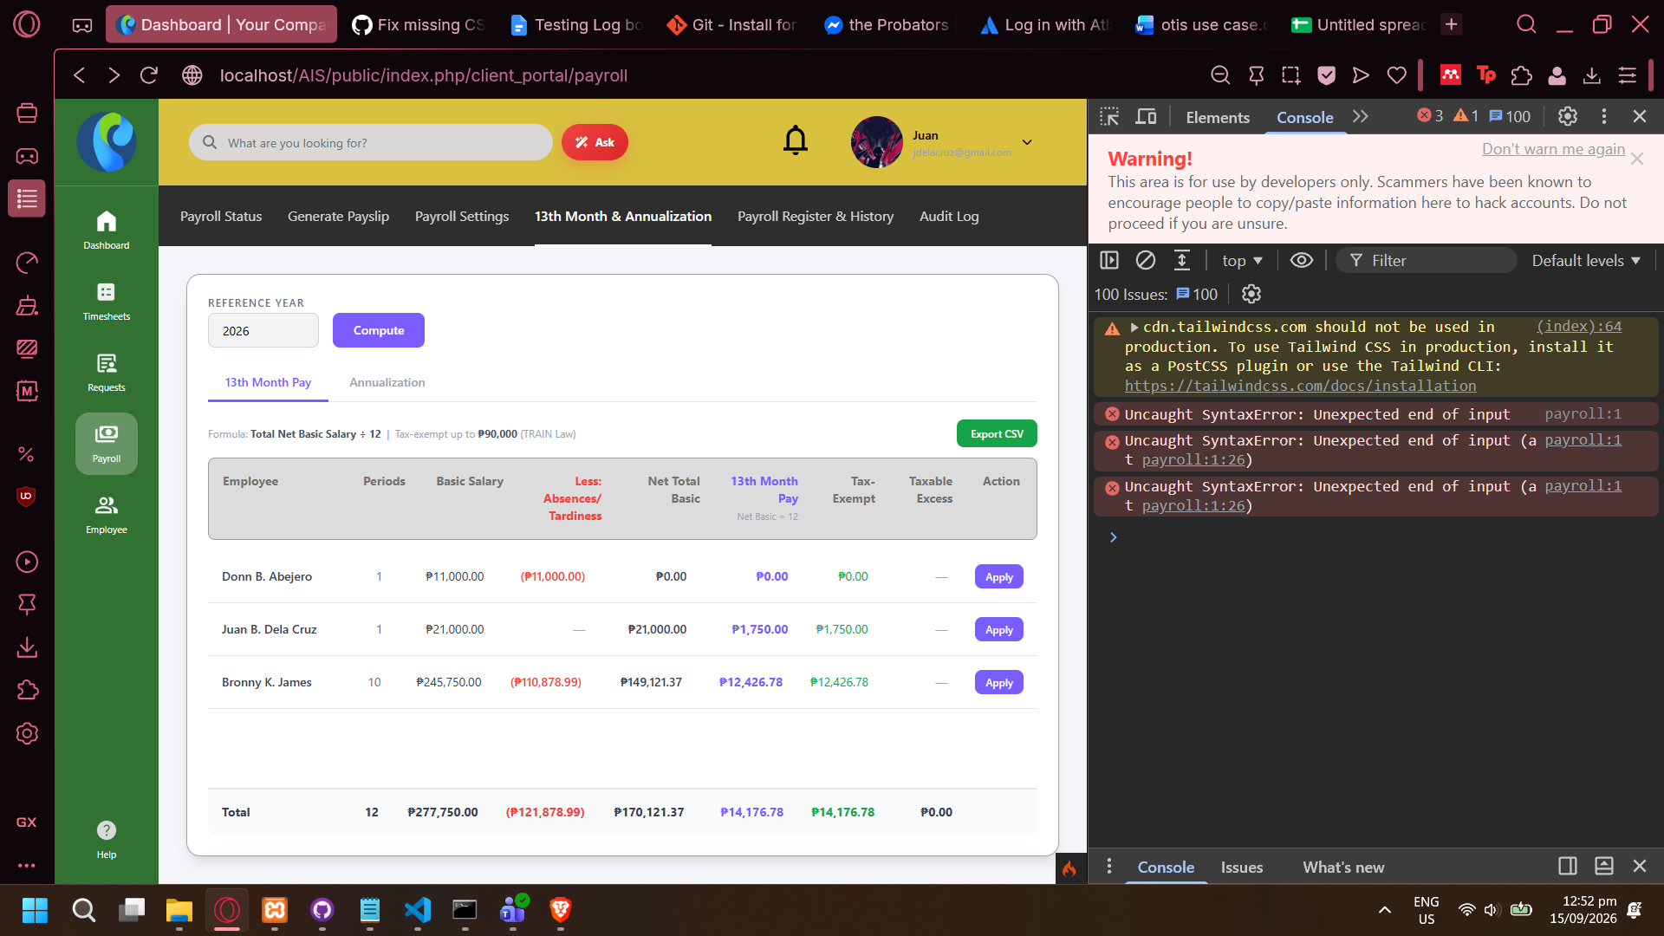
- Only one printed console log error per employee. Any further attempts (clicking the Apply button again) does not result in another error being printed into console log.
- Console log error: Uncaught SyntaxError: Unexpected end of input (at payroll:1:26)
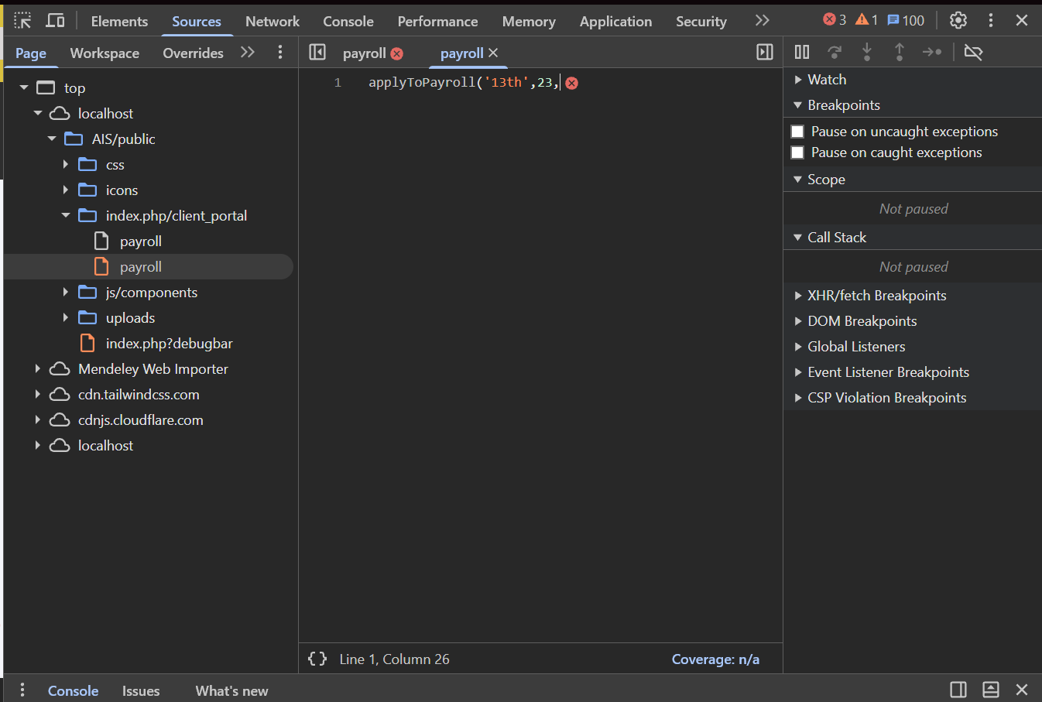

Cannot apply annualization
Marked as Needs Retest
- Similar problem to Cannot apply 13th pay bug
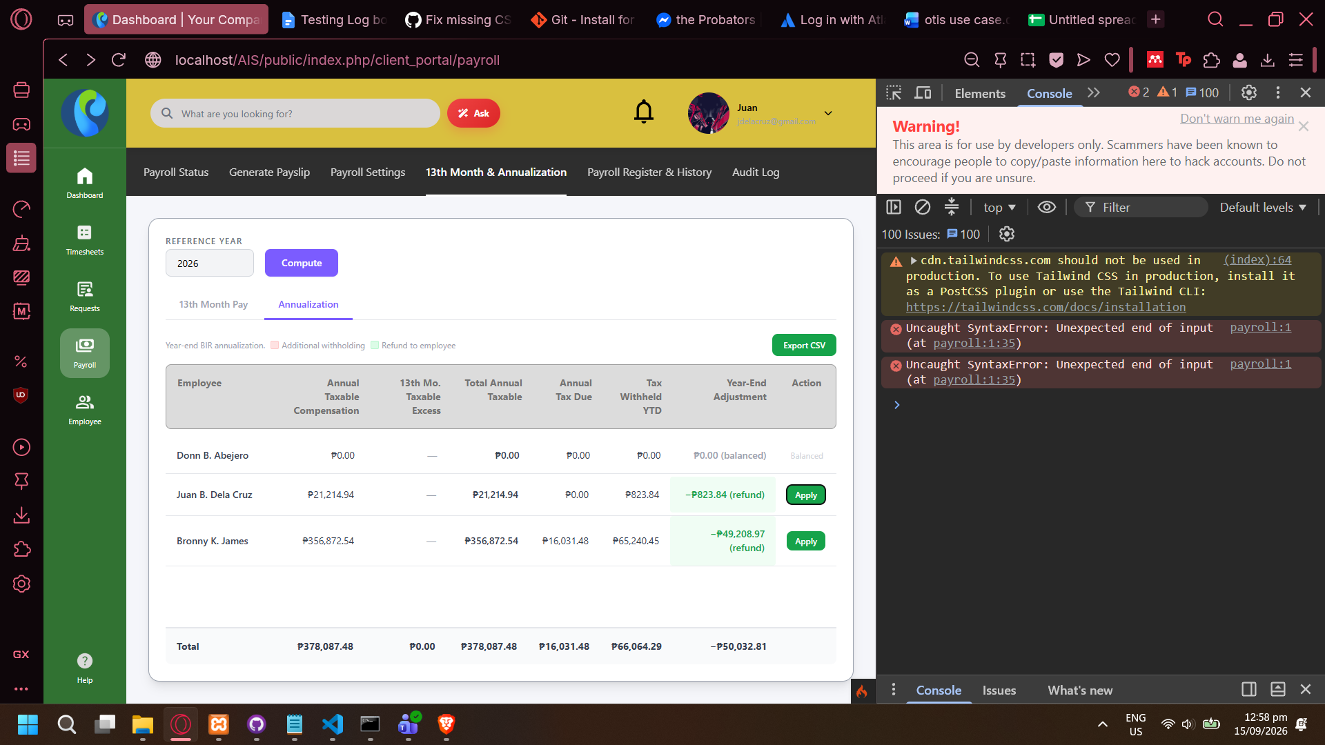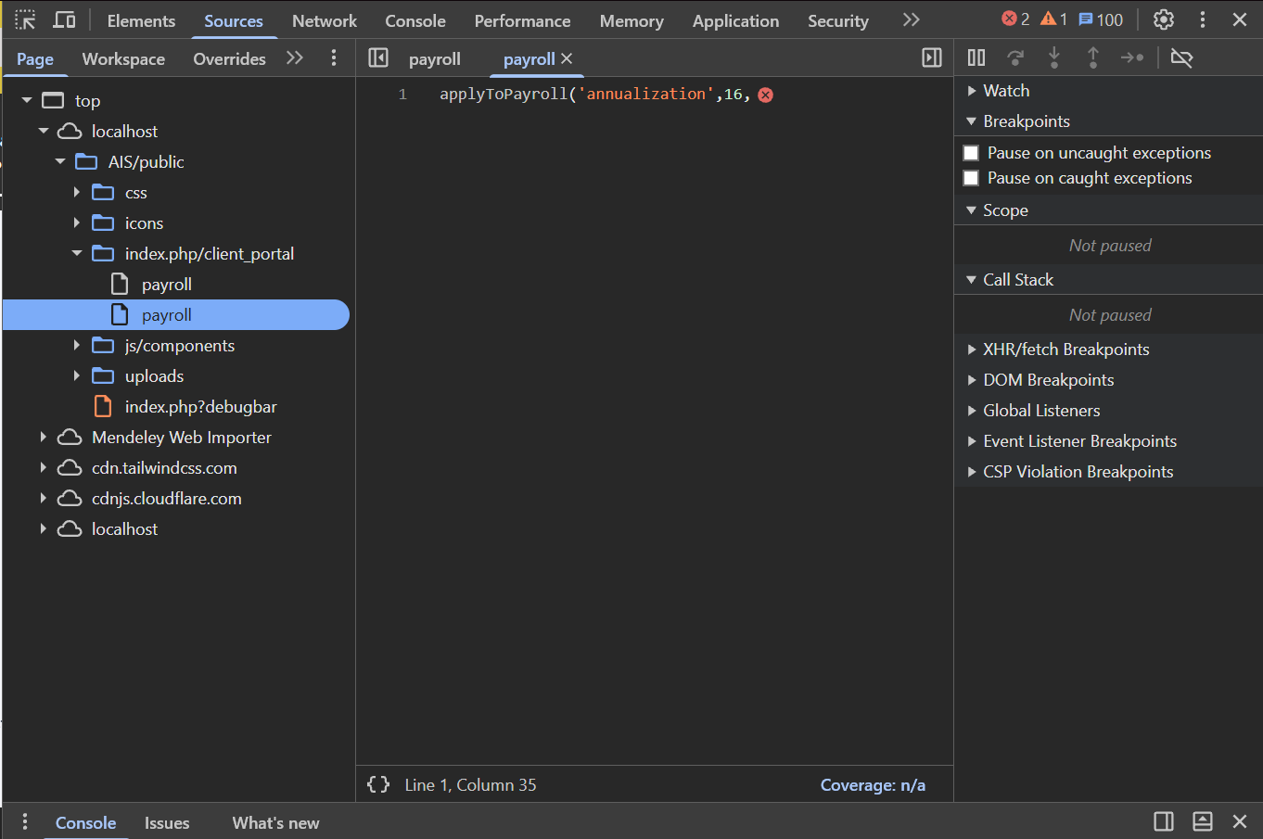

Loading symbol in Bulk Send is not distinct
Marked as Needs Retest
- Loading is detoned by an ellipses that replaces the button’s text. It was not clear that it was loading until the Sent validation came in.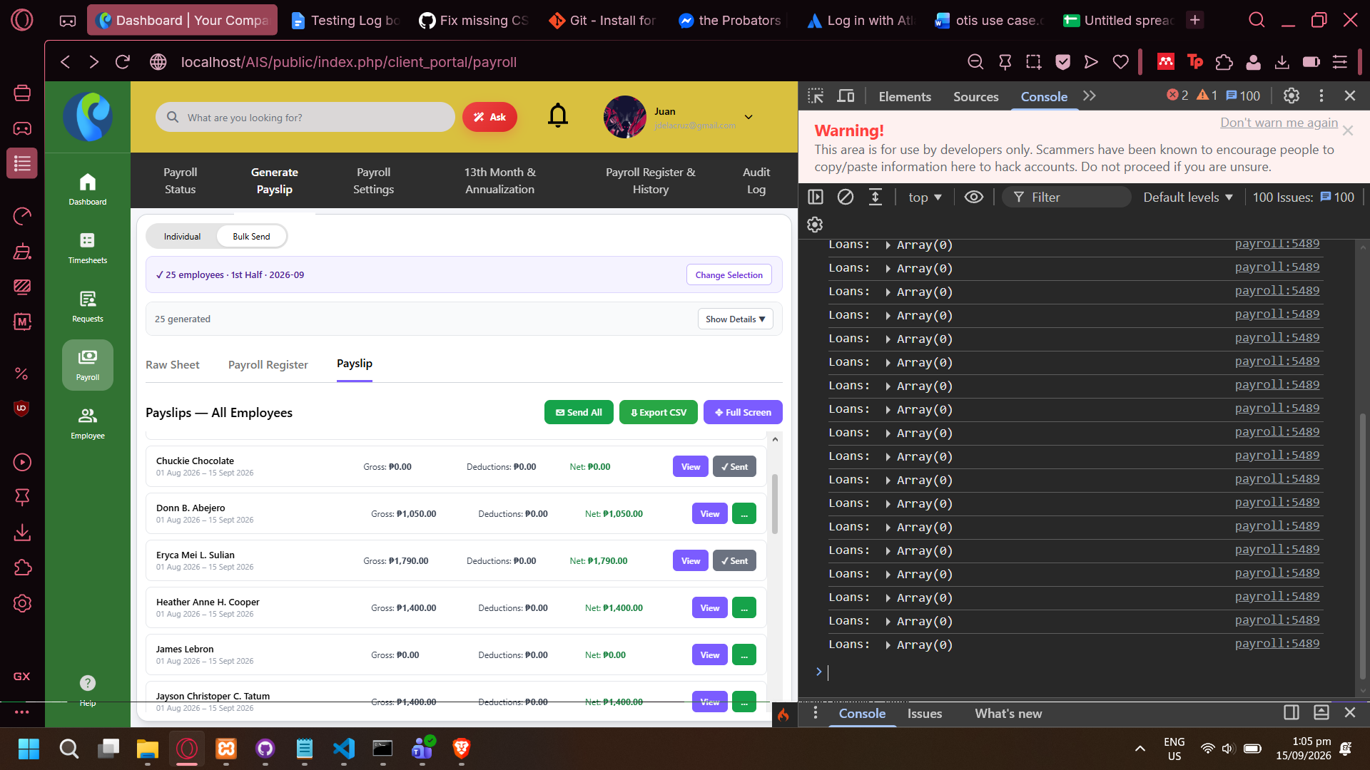

Send All in Bulk Send triggers actions but no validation feedback is provided
Marked as Needs Retest
- No validation feedback that the payslips are being sent, but the action is triggered.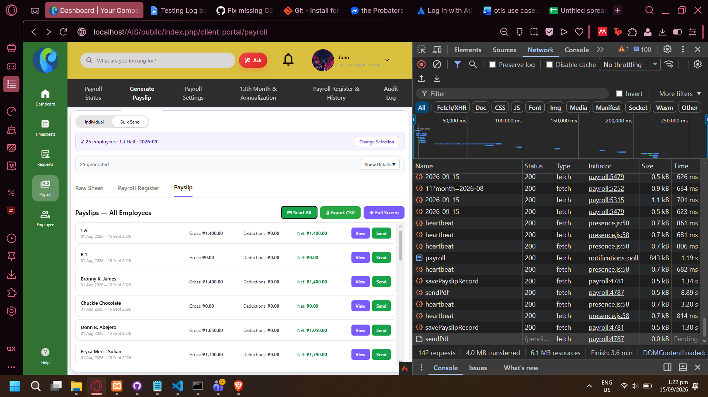

(QA Not sure if bug) View request waits for payslips to be sent
Marked as Needs Retest
- View request is not concurrent with Send requests. If user Sent payslips before clicking View button, system waits until all previous requests are finished.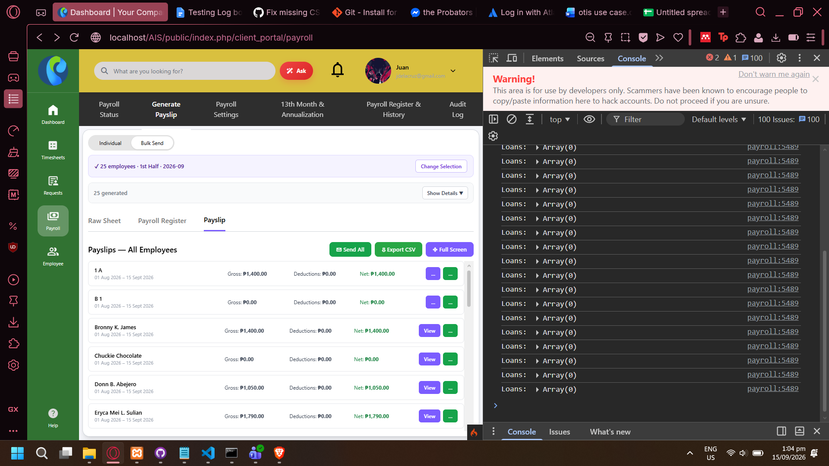

Testing Log Date: 09/17/26

New Employee form
- Negative amounts, wrong government ID formats, and wrong mobile number formats do not pass validation, but when submitting form the page reloads and does not show any validation error message that the employee was not added.
  - ON VPS: Validation error pops up during the reload screen
- There is in-form validation for email and password, but not on other fields, but is not validated upon submitted anyway

Adding New Employee without name does not show validation error
- Error is only seen in console log, no validation error pop-up or message is shown on page.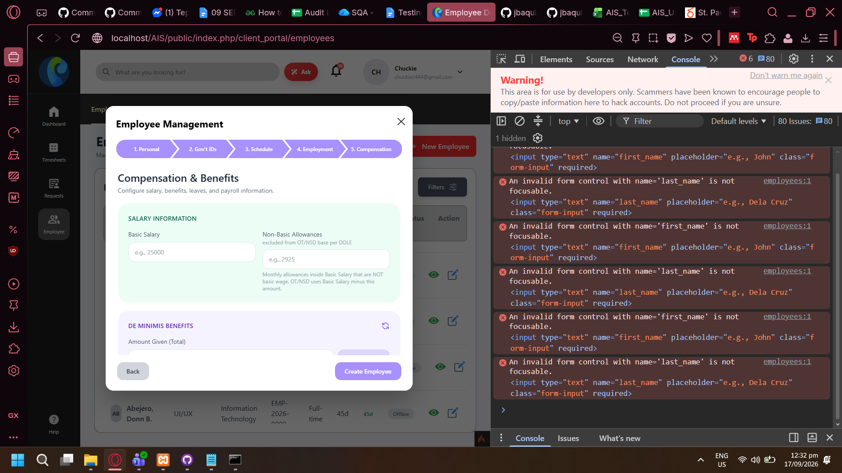

LIVE Test Log Date: 09/18/2026
Testing on Live

No validation error message when trying to add employee without name input
- No validation error message is shown when trying to add employee with no first_name or last_name. Error is only seen in console log.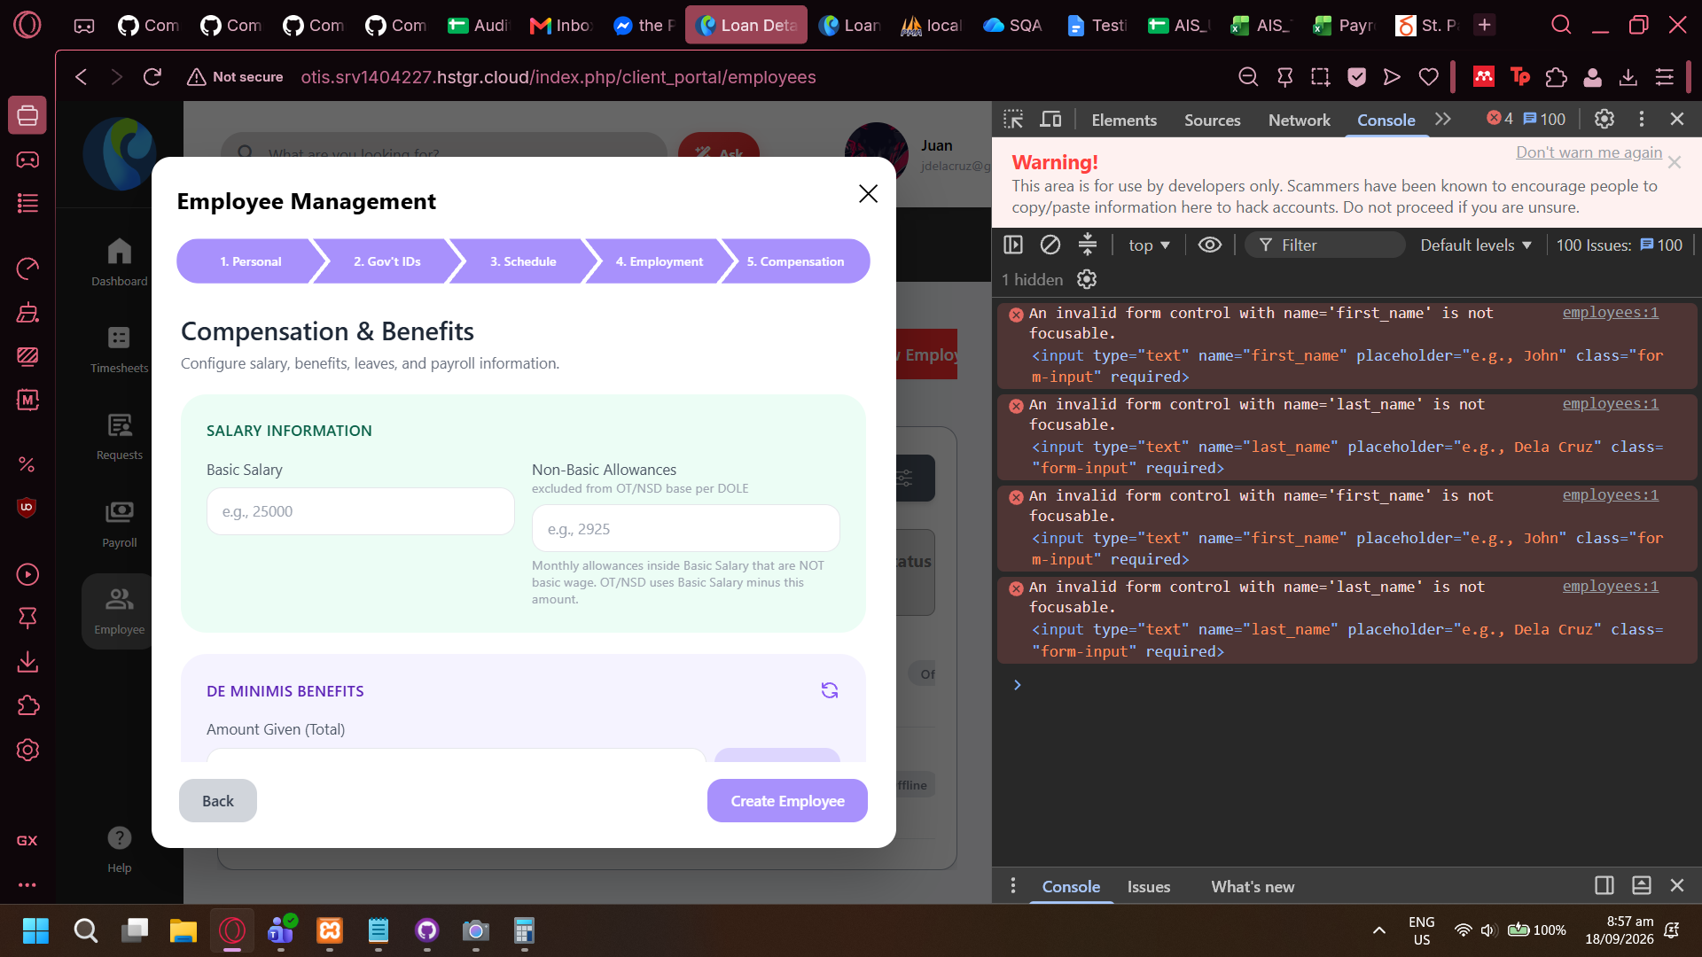
- If the user enters with blank name input, form validates for the input. If user does not interact with the field at all, proceeding with next does not show any validation message.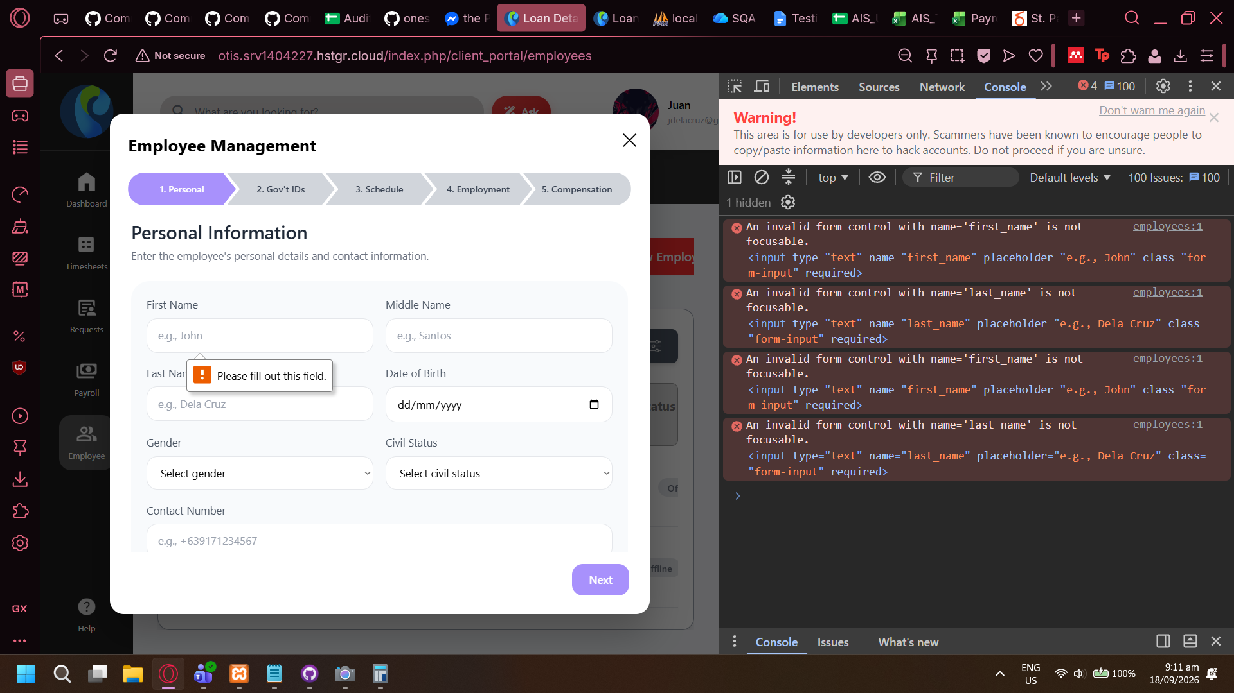

Wrong Favicon shown when not logged in
- Codeigniter favicon is used when logged out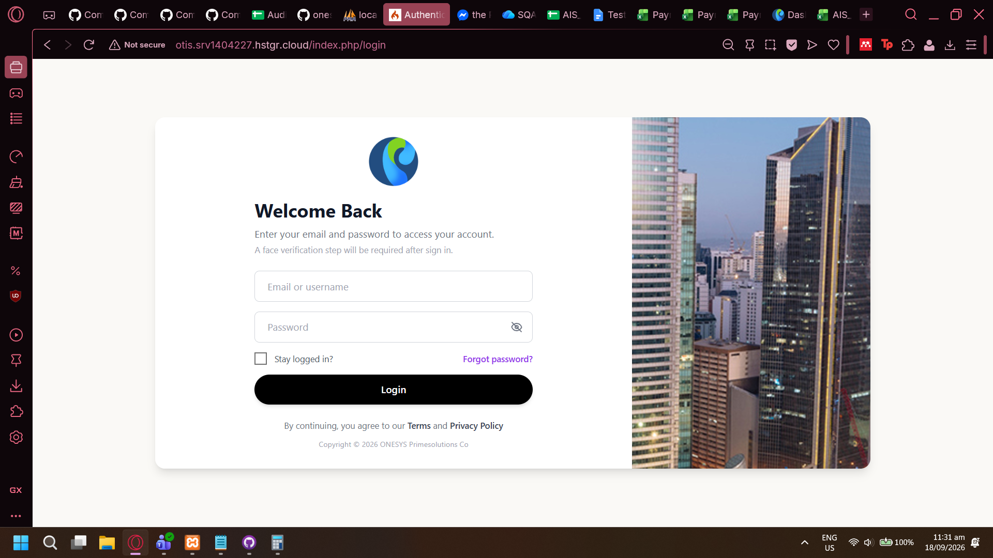
- Once a user logs in the favicon changes to the company logo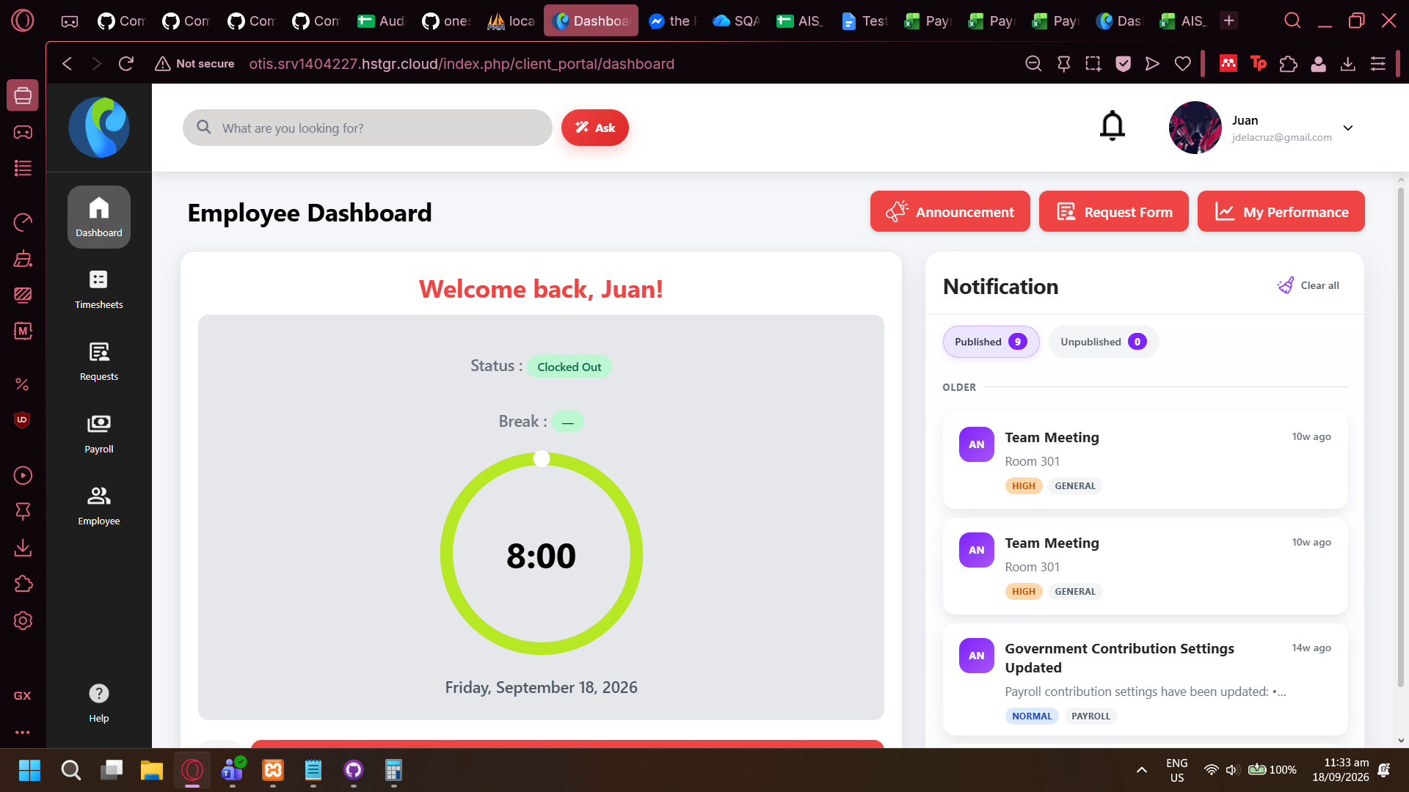

Update photo does not work
- User is prompted to upload photo from their device but nothing happens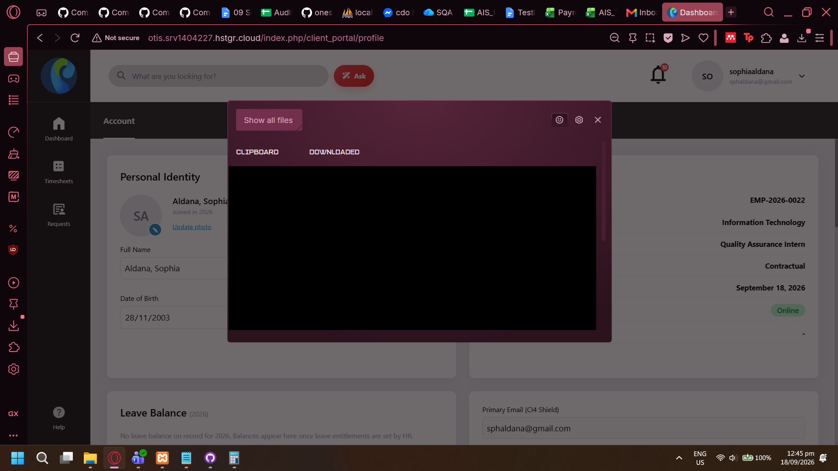
- No console log is generated either.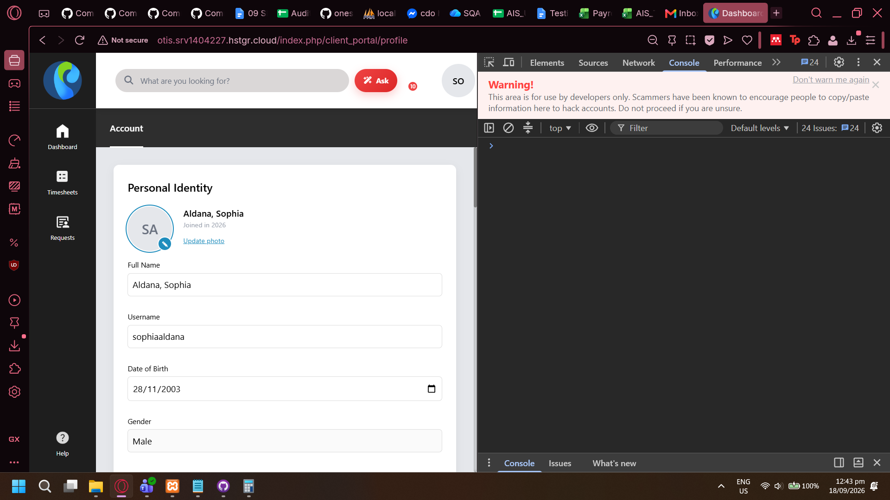

Cannot save correction on flagged attendance
- Dev error is displayed on page error message on Live System.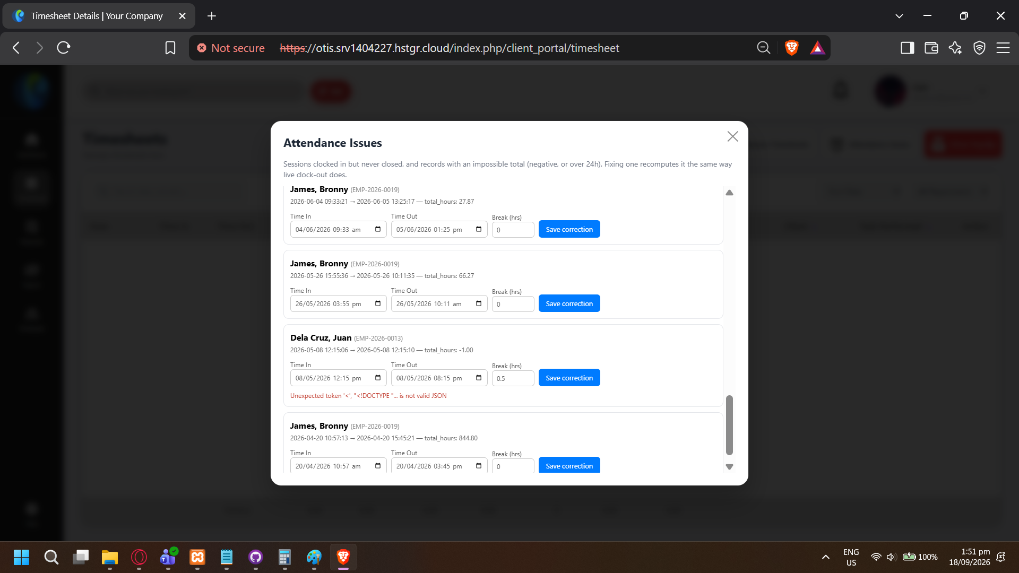
- Local Host only shows “The action you requested is not allowed” (using jdelacruz account)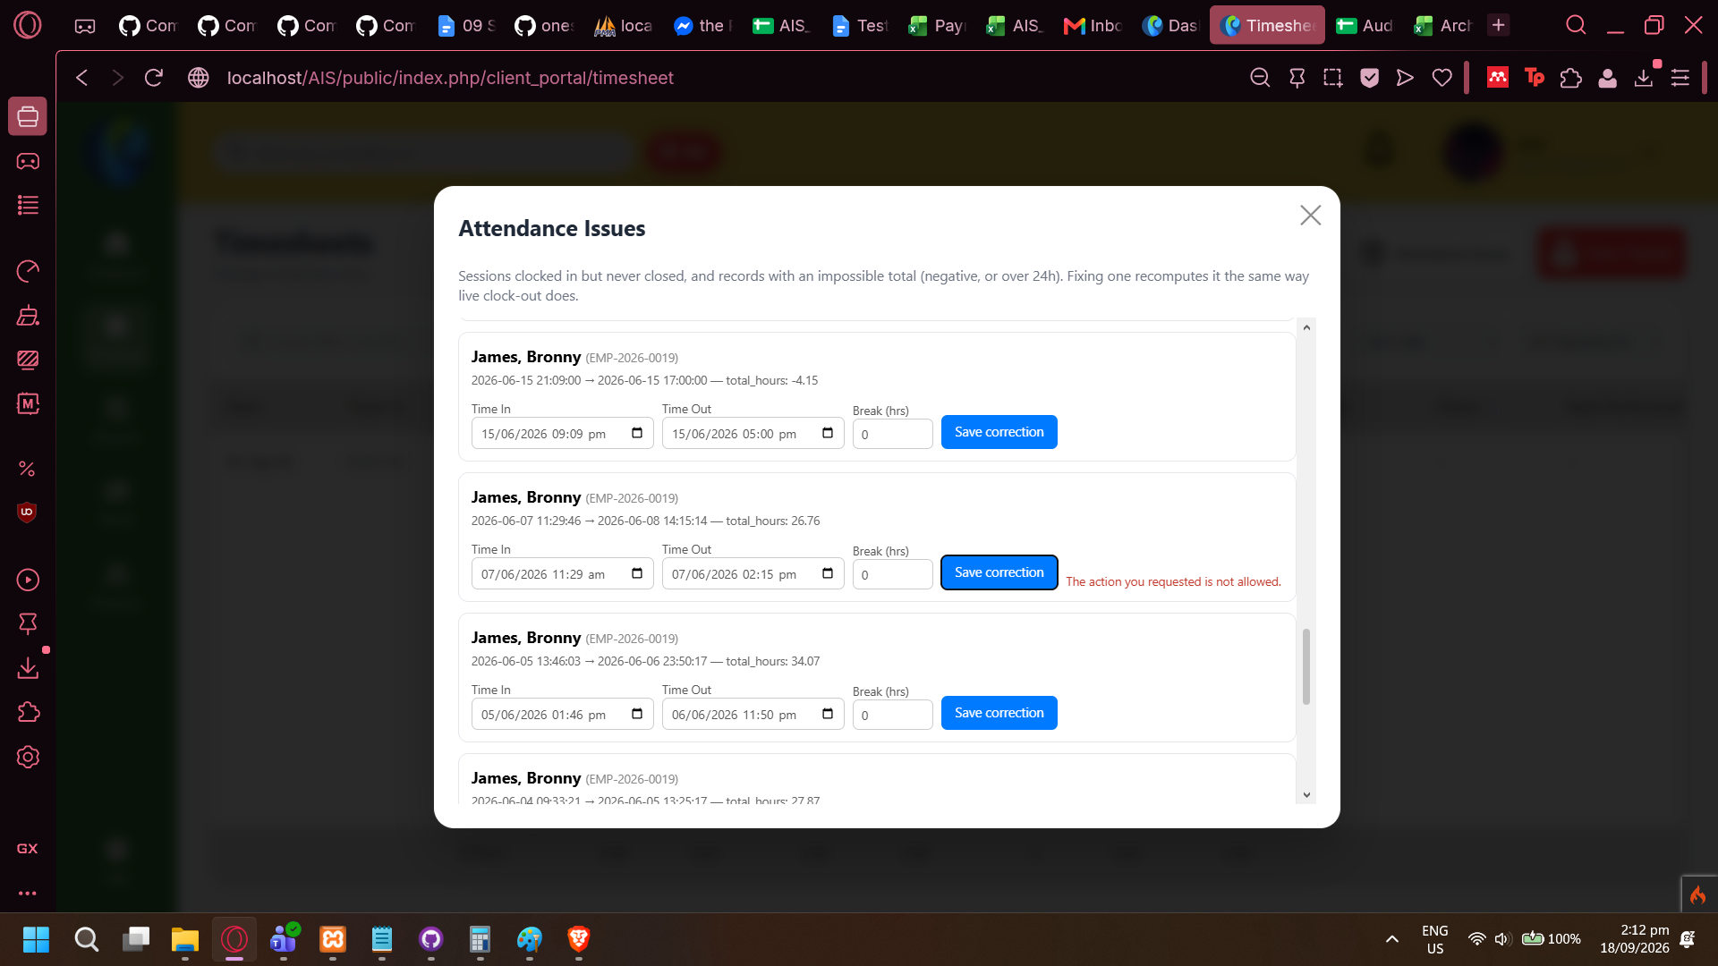

Minor Issue: Session only checks user ID and not other identifying information
- Note: issue only occurred because Admin re-imported database while QA was logged in.
- After re-importing the database, QA’s logged-in session changed users. (QA logged in with sphaldana@gmail.com, and after database re-import QA was suddenly logged-in akademus@mentora.com)
- The issue only arose from non-typical behavior but points to a session validation design issue.

Edit Employee Modal does not save inputs
- Modal does not save data input before submission. When modal closes, all fields are refreshed.

LIVE Test Log Date: 09/21/2026

Task Log does not accept time input outside of preset values
marked as: fixed 2026/09/21, done by Stanley
- System does not allow non-preset values (e.g. cannot mark end of task as 10:46, defaults to 10:45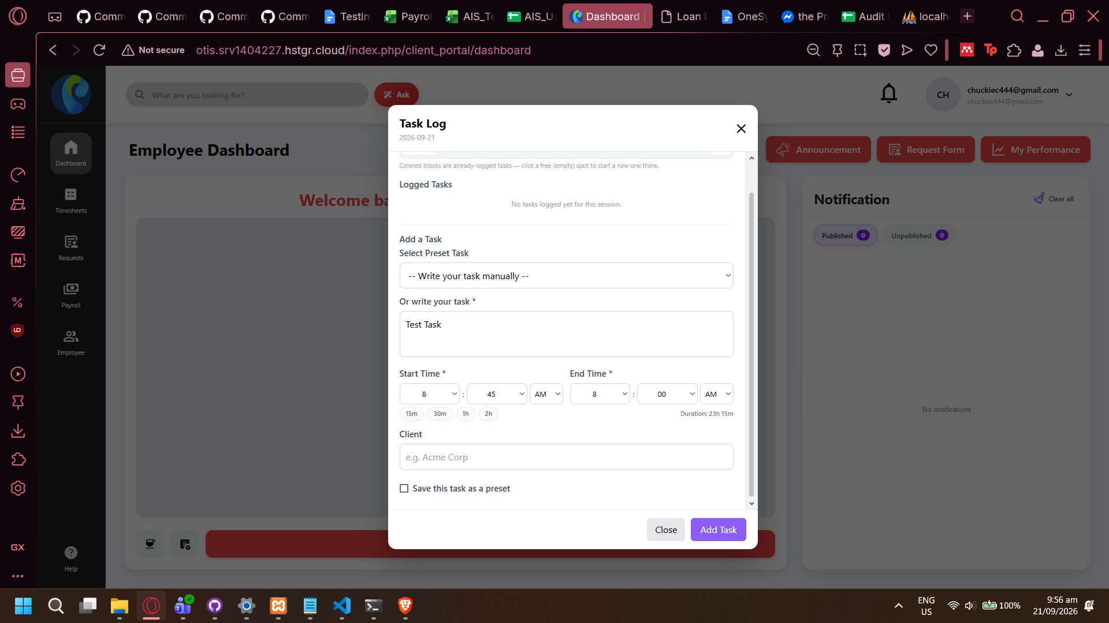

(TS_03) Edit Task not functional
- clicking Edit button on a Logged Task does not do anything. No validation error message is shown on page or in console lo.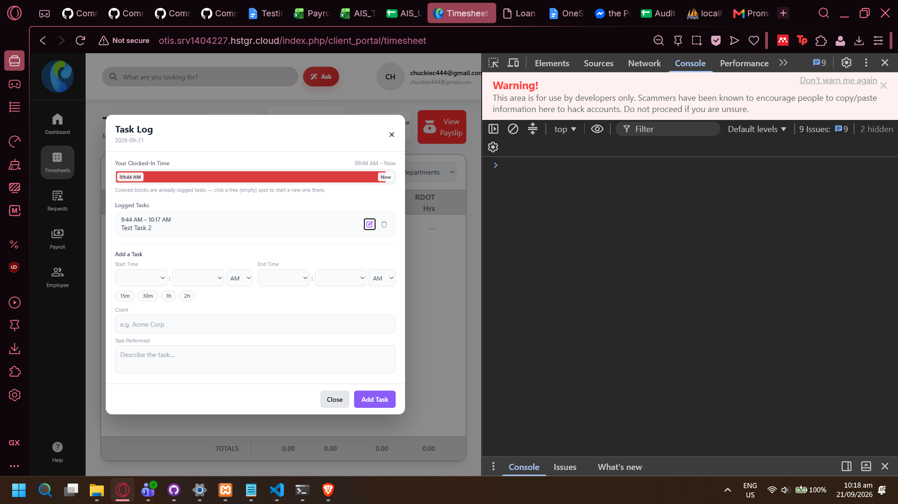
- Delete is still functional though.

BL-029: (TS-04) Admin cannot update/correct employees attendance entry
- No option to edit timesheet. QA assumes TS-04 is supposed to be related to ATT_06 and can only change the timesheet if it is flagged, but QAis unsure. See AIS Test Cases here
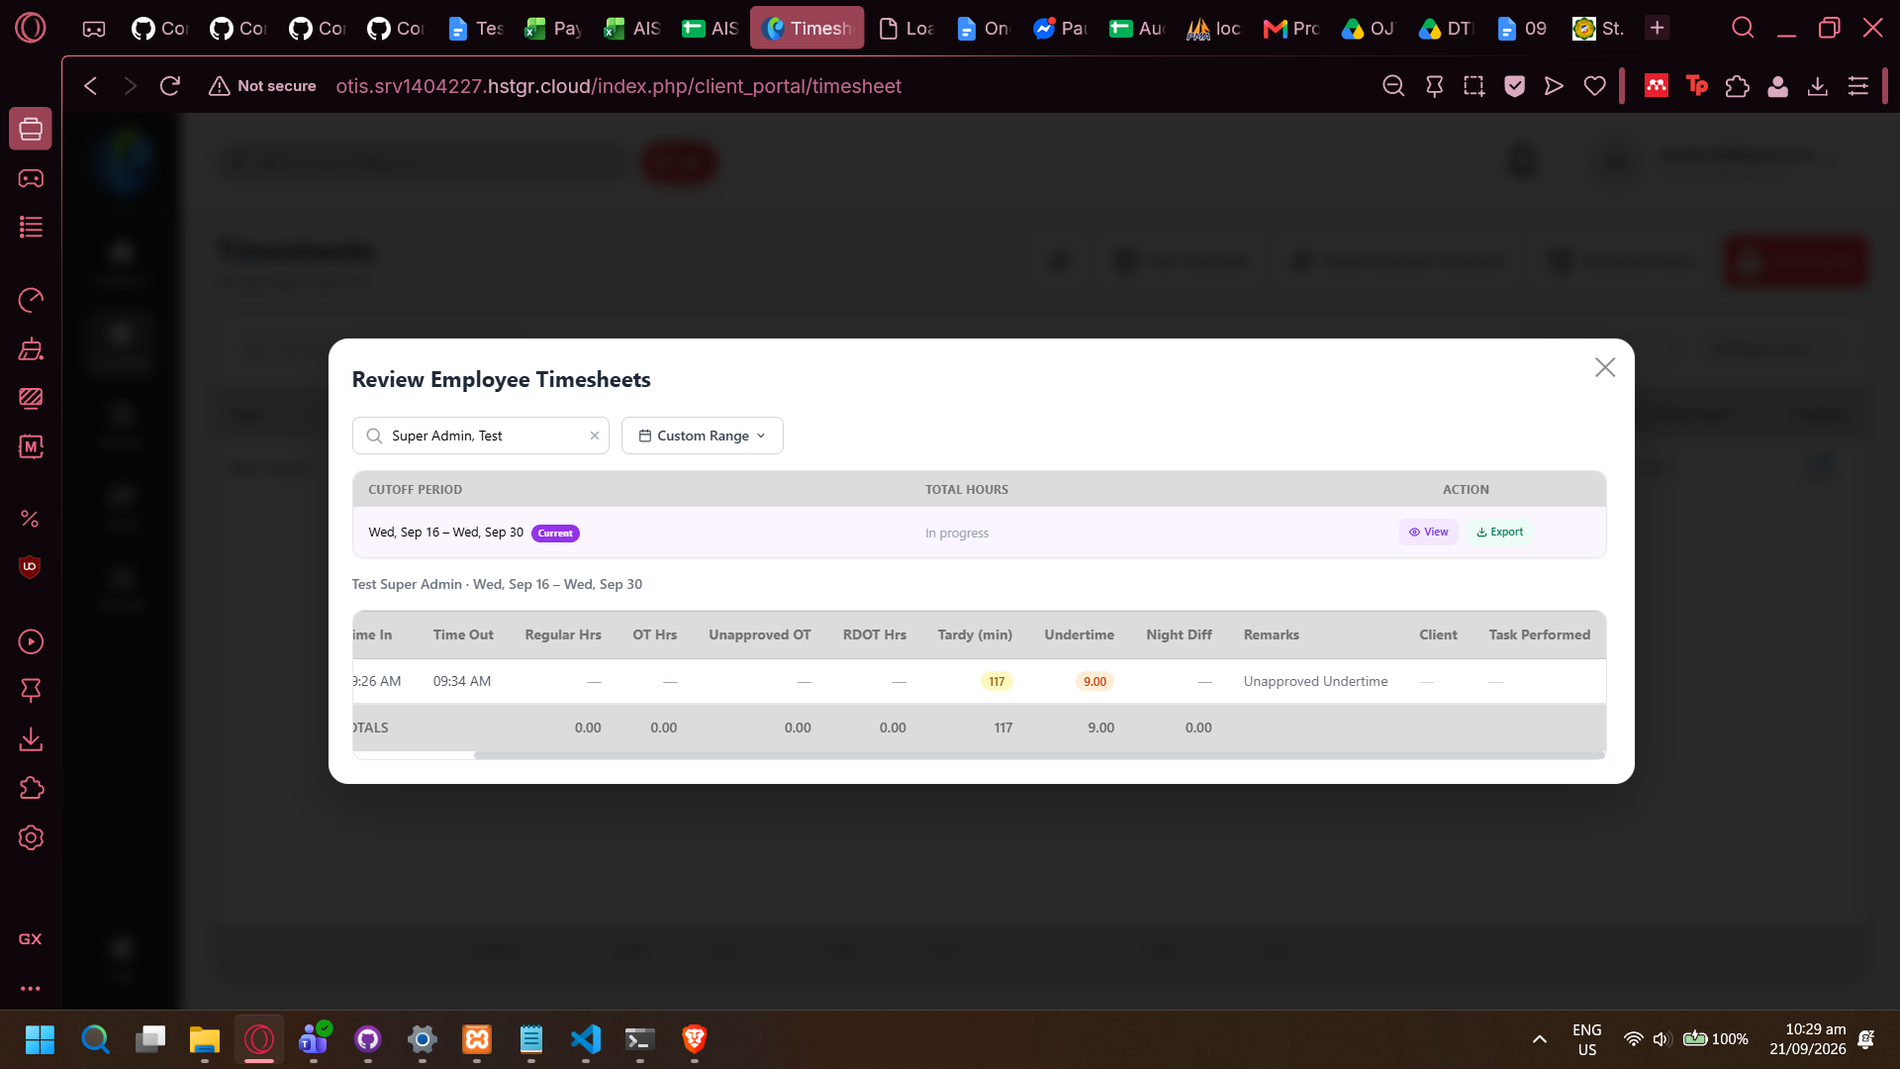

BL-030: Task Log displays save error even if task is saved, related to Client Presets
- When saving a new Task where `Save this client as a preset` is checked, page displays error message “Unable to save task” but task is actually saved.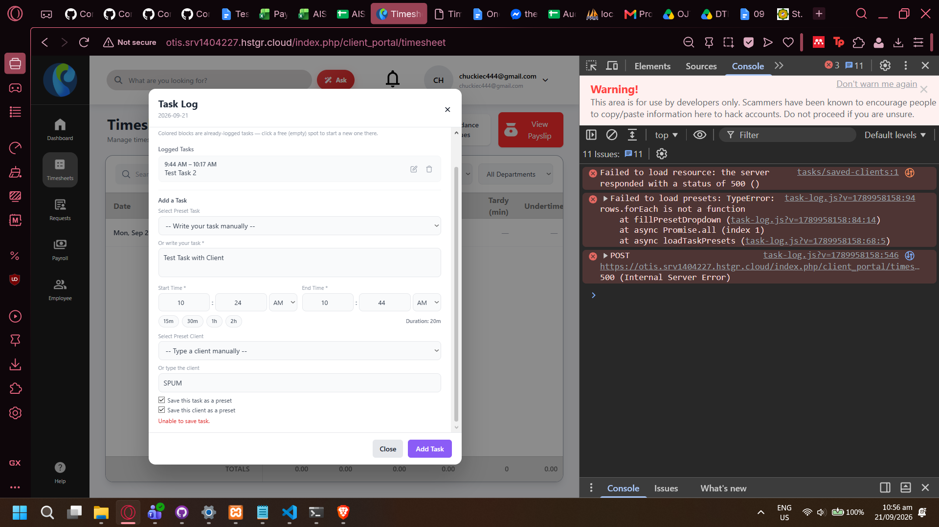
- Upon loading of Task Log, the first two console error logs are displayed (as seen in screenshot above)

LIVE Test Log Date: 09/22/2026

BL-031: Minor Issue: Error messages on New Loan Form
- NOTE: This was tested on Live System. QA’s local copy (using myBranch) rectifies the issues stated in this Bug Log
- Warning says “Please complete all required fields” even if all fields have input (although Principle Amount has “0” for input)
- Negative amount allows user to proceed to next page of form even if amount is invalid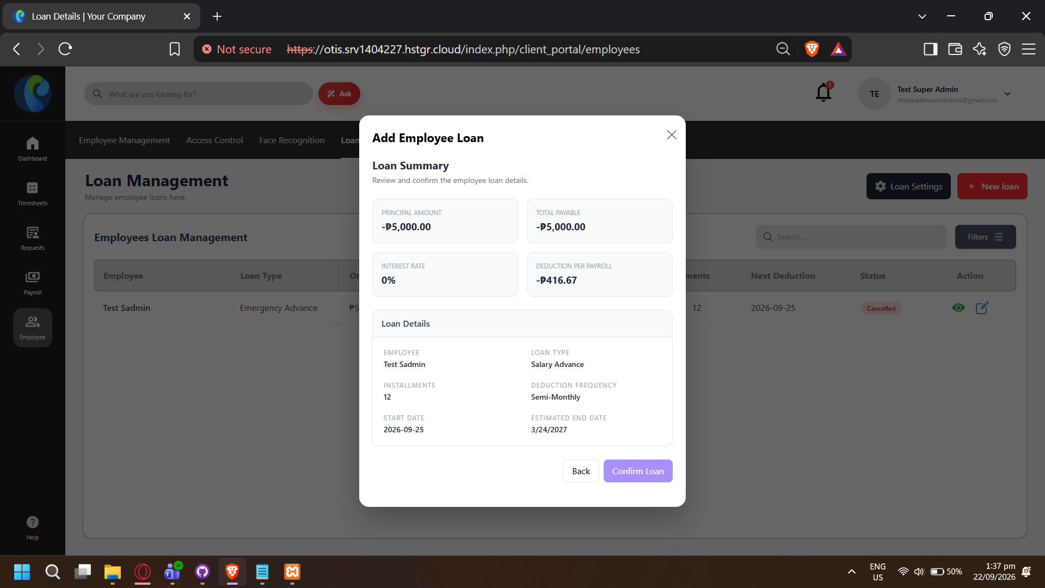
- Works as expected, invalid inputs are rejected, but validation errors are not standardized across form.

BL-032: Broken UI on Loan Details
- Balance After and Status are stuck together.